# Analyze data in a lake database

Azure Synapse Analytics enables you to combine the flexibility of file storage in a data lake with the structured schema and SQL querying capabilities of a relational database through the ability to create a lake database. A lake database is a relational database schema defined on a data lake file store that enables data storage to be separated from the compute used to query it. Lake databases combine the benefits of a structured schema that includes support for data types, relationships, and other features typically only found in relational database systems, with the flexibility of storing data in files that can be used independently of a relational database store. Essentially, the lake database “overlays” a relational schema onto files in folders in the data lake.

This exercise should take approximately ****45**** minutes to complete.

## Before you start

You’ll need an [Azure subscription](https://azure.microsoft.com/free) in which you have administrative-level access.

## Provision an Azure Synapse Analytics Workspace

To support a lake database, you need an Azure Synapse Analytics workspace with access to data lake storage. There is no need for a dedicated SQL pool, since you can define the lake database using the built-in serverless SQL pool. Optionally, you can also use a Spark pool to work with data in the lake database.

In this exercise, you’ll use a combination of a PowerShell script and an ARM template to provision an Azure Synapse Analytics workspace.

1. Sign into the [Azure portal](https://portal.azure.com/) at https://portal.azure.com.
2. Use the ****[>_]**** button to the right of the search bar at the top of the page to create a new Cloud Shell in the Azure portal, selecting a **PowerShell** environment and creating storage if prompted. The cloud shell provides a command line interface in a pane at the bottom of the Azure portal, as shown here:

[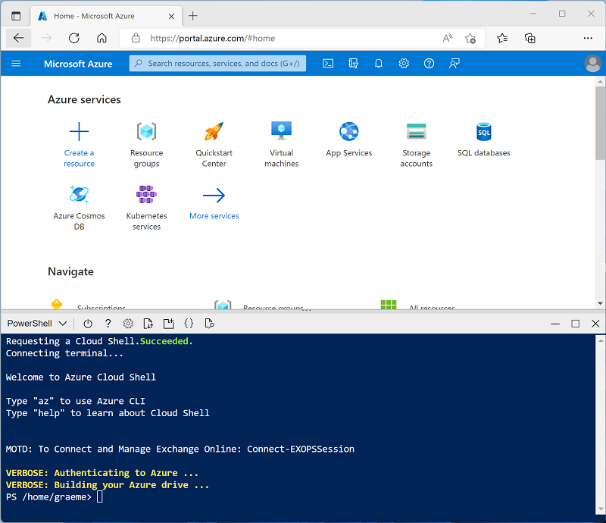](https://microsoftlearning.github.io/dp-203-azure-data-engineer/Instructions/Labs/images/cloud-shell.png)

****Note****: If you have previously created a cloud shell that uses a Bash environment, use the the drop-down menu at the top left of the cloud shell pane to change it to **PowerShell**.

1. Note that you can resize the cloud shell by dragging the separator bar at the top of the pane, or by using the ****—****, ****◻****, and ****X**** icons at the top right of the pane to minimize, maximize, and close the pane. For more information about using the Azure Cloud Shell, see the [Azure Cloud Shell documentation](https://docs.microsoft.com/azure/cloud-shell/overview).
2. In the PowerShell pane, enter the following commands to clone this repo:

rm -r dp-203 -f

git clone https://github.com/MicrosoftLearning/dp-203-azure-data-engineer dp-203

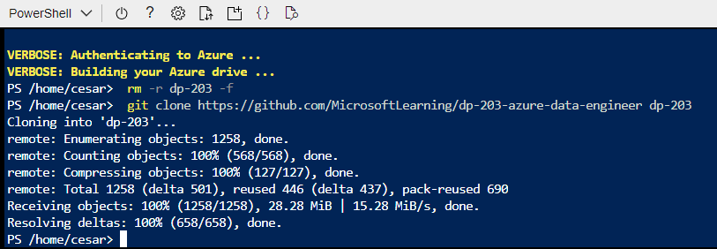

1. After the repo has been cloned, enter the following commands to change to the folder for this exercise and run the ****setup.ps1**** script it contains:

cd dp-203/Allfiles/labs/04

./setup.ps1

1. If prompted, choose which subscription you want to use (this will only happen if you have access to multiple Azure subscriptions).
2. When prompted, enter a suitable password to be set for your Azure Synapse SQL pool.

****Note****: Be sure to remember this password!

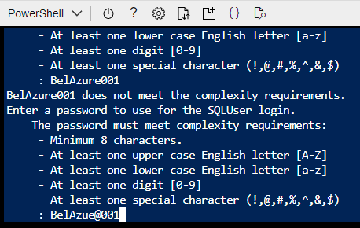

1. Wait for the script to complete - this typically takes around 10 minutes, but in some cases may take longer. While you are waiting, review the [Lake database](https://docs.microsoft.com/azure/synapse-analytics/database-designer/concepts-lake-database) and [Lake database templates](https://docs.microsoft.com/azure/synapse-analytics/database-designer/concepts-database-templates) articles in the Azure Synapse Analytics documentation.

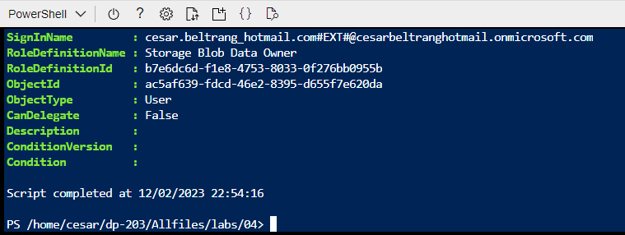

## Modify container permissions

1. After the deployment script has completed, in the Azure portal, go to the ****dp203-**xxxxxxx** resource group that it created, and notice that this resource group contains your Synapse workspace, a Storage account for your data lake, and an Apache Spark pool.

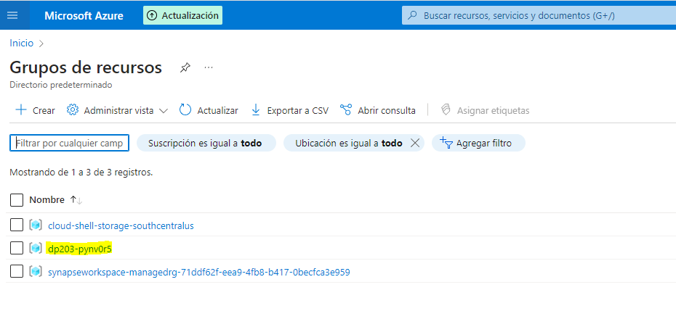

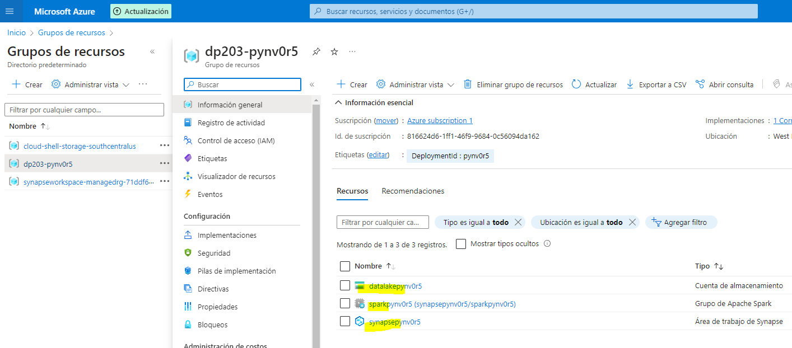

1. Select the ****Storage account**** for you data lake named ****datalakexxxxxxx****

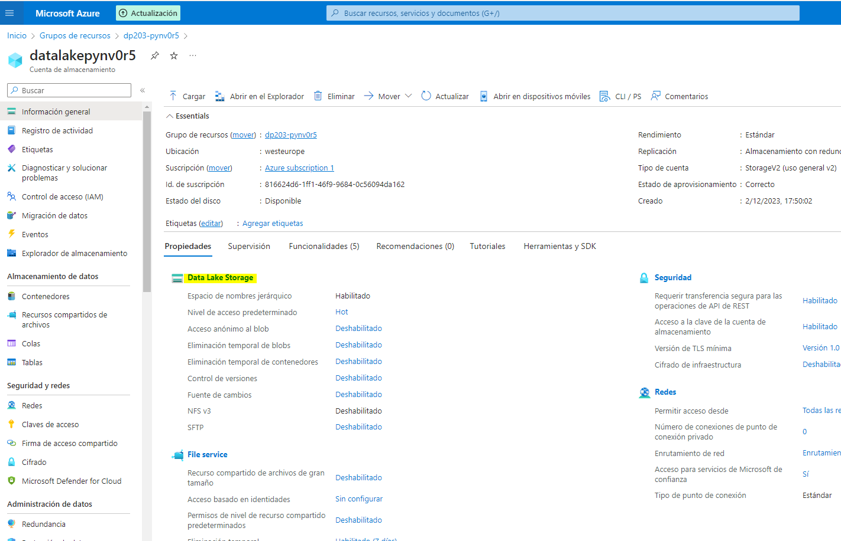

1. Within the ****datalakexxxxxx**** container, select the ****files folder****

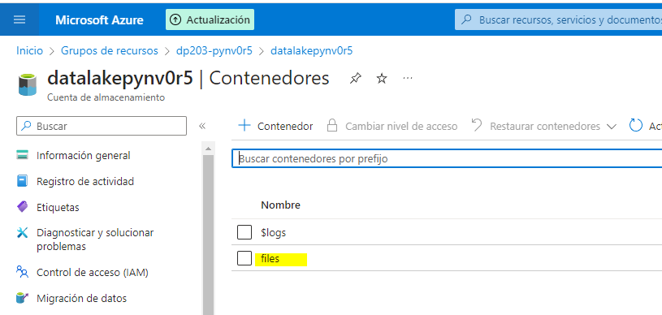

1. Within the ****files folder**** you’ll note the ****Authentication method:**** is listed as **Access key (Switch to Azure AD User Account)** click on this to change to Azure AD User Account.

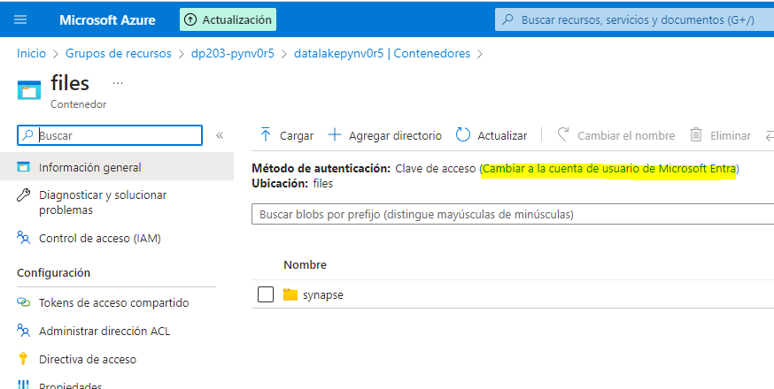

Cambiada:

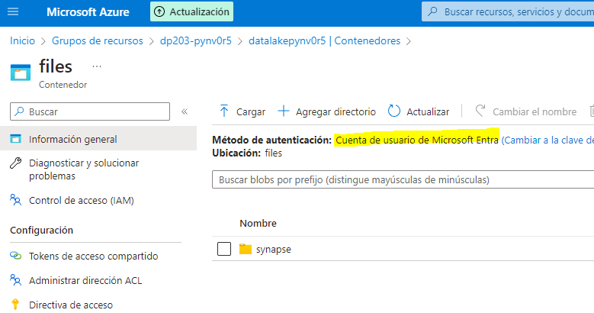

## Create a lake database

A lake database is a type of database that you can define in your workspace, and work with using the built-in serverless SQL pool.

1. Select your Synapse workspace, and in its ****Overview**** page, in the ****Open Synapse Studio**** card, select ****Open**** to open Synapse Studio in a new browser tab; signing in if prompted.

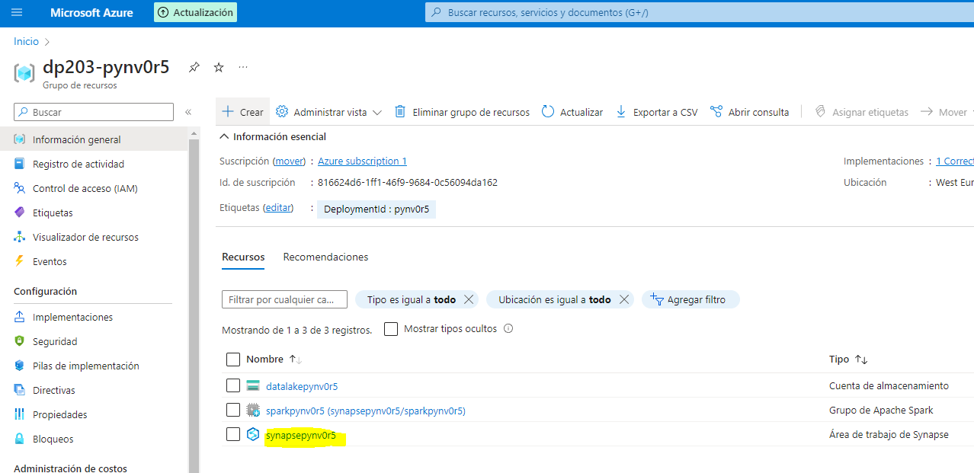

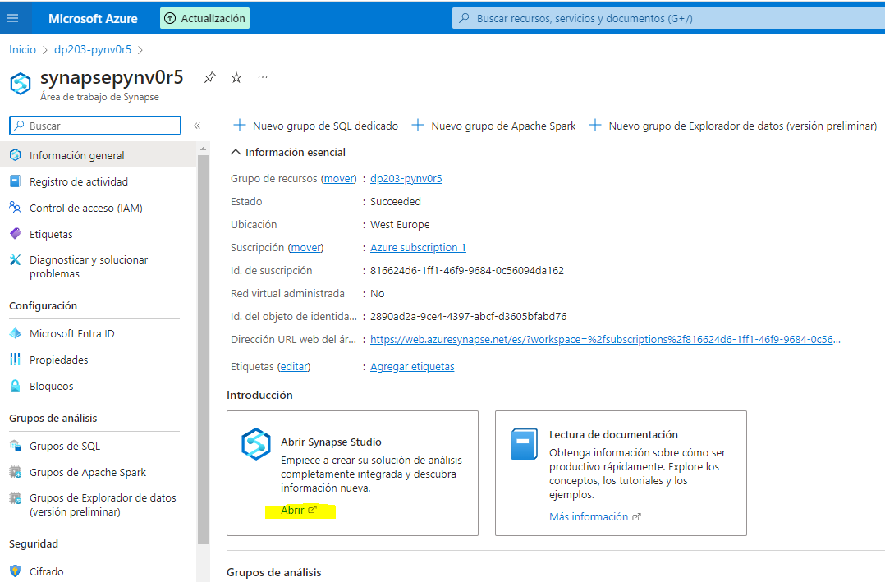

1. On the left side of Synapse Studio, use the ****››**** icon to expand the menu - this reveals the different pages within Synapse Studio that you’ll use to manage resources and perform data analytics tasks.
2. On the ****Data**** page, view the ****Linked**** tab and verify that your workspace includes a link to your Azure Data Lake Storage Gen2 storage account.

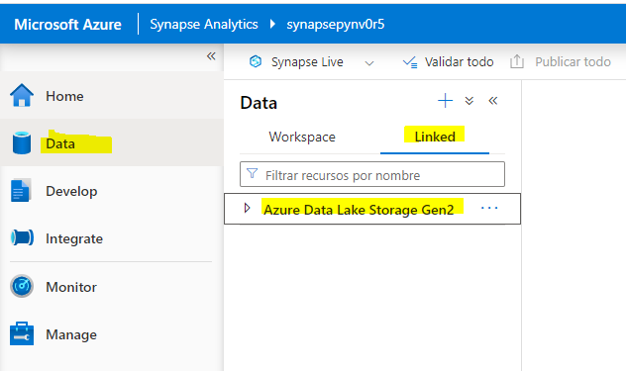

1. On the ****Data**** page, switch back to the ****Workspace**** tab and note that there are no databases in your workspace.

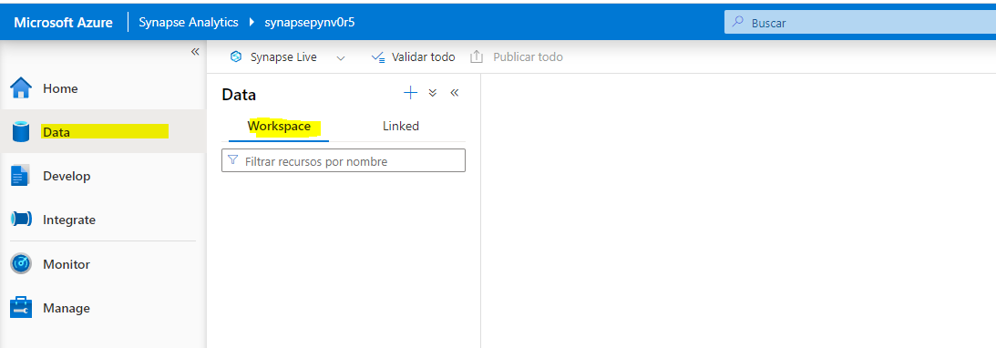

1. In the ****+**** menu, select ****Lake database**** to open a new tab in which you can design your database schema (accepting the database templates terms of use if prompted).

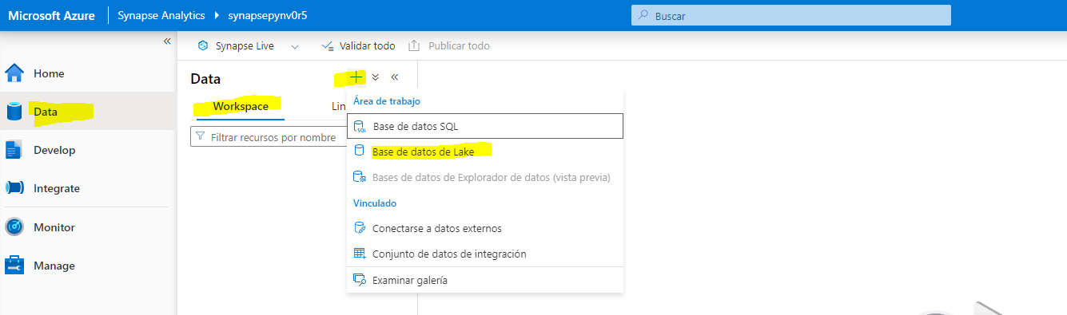

1. In the ****Properties**** pane for the new database, change the ****Name**** to ****RetailDB**** and verify that the ****Input folder**** property is automatically updated to ****files/RetailDB****. Leave the ****Data format**** as ****Delimited Text**** (you could also use Parquet format, and you can override the file format for individual tables - we’ll use comma-delimited data in this exercise.)

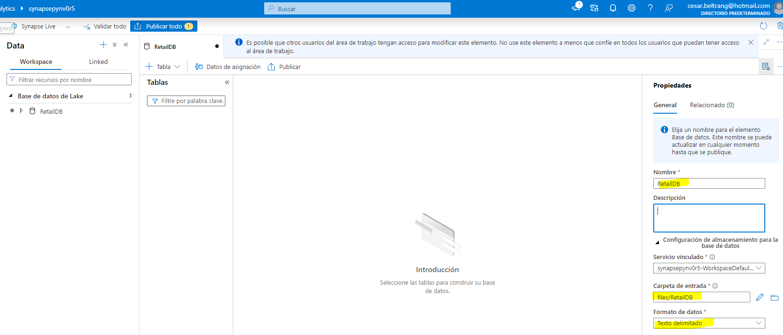

1. At the top of the ****RetailDB**** pane, select ****Publish**** to save the database so far.

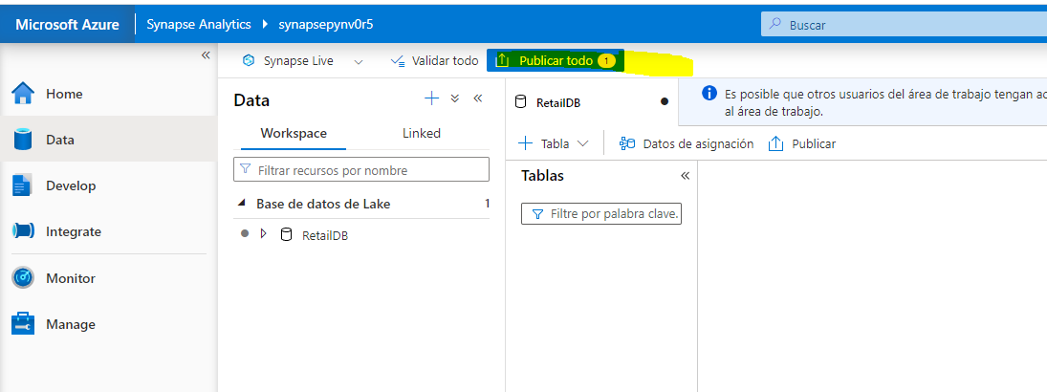

1. In the ****Data**** pane on the left, view the ****Linked**** tab. Then expand ****Azure Data Lake Storage Gen2**** and the primary ****datalake**xxxxxxx** store for your ****synapse**xxxxxxx** workspace, and select the ****files**** file system; which currently contains a folder named ****synapse****.

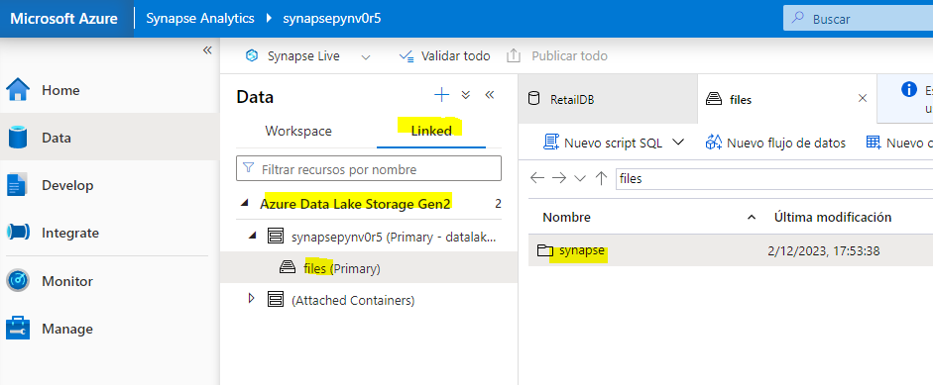

1. In the ****files**** tab that has opened, use the ****+ New folder**** button to create a new folder named ****RetailDB**** - this will be the input folder for the data files used by tables in your database.

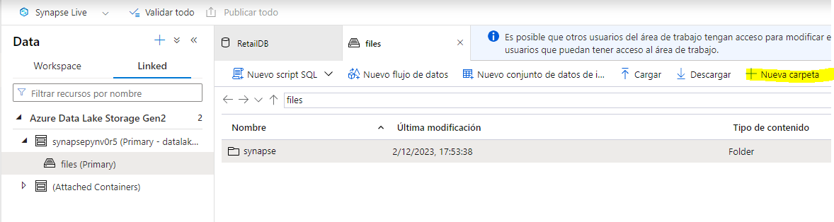

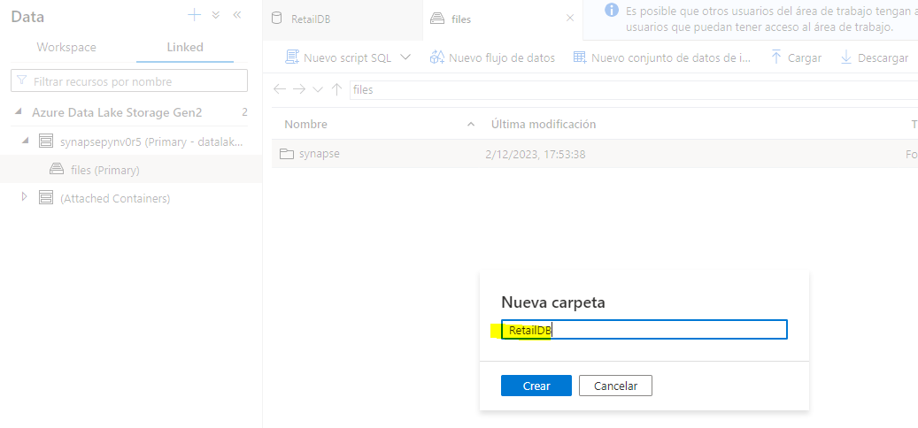

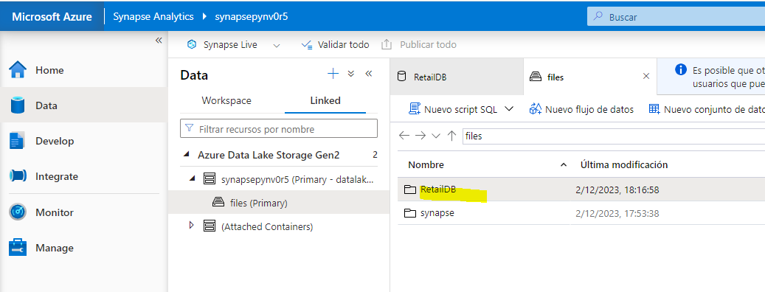

## Create a table

Now that you have created a lake database, you can define its schema by creating tables.

### Define the table schema

1. Switch back to the ****RetailDB**** tab for your database definition, and in the ****+ Table**** list, select ****Custom****, and note that a new table named ****Table_1**** is added to your database.

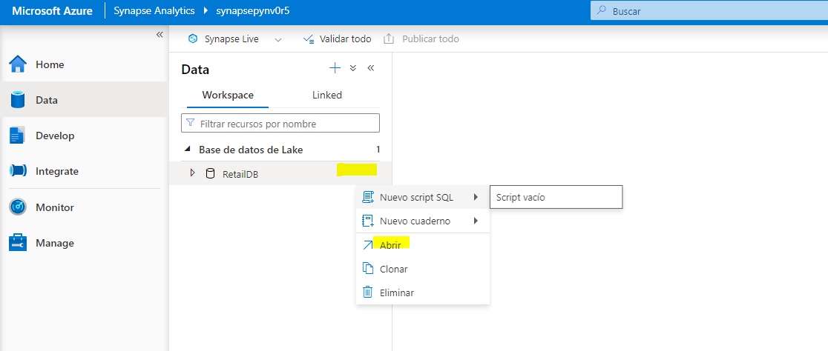

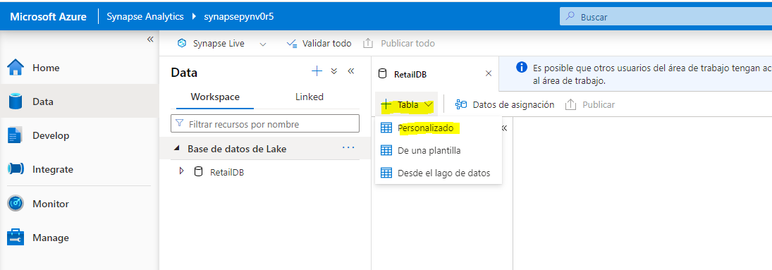

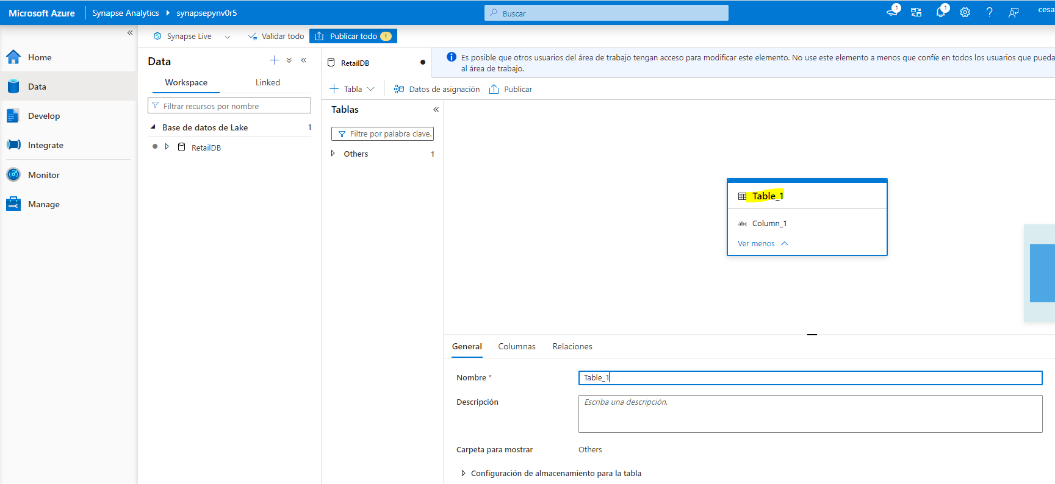

1. With ****Table_1**** selected, in the ****General**** tab under the database design canvas, change the ****Name**** property to ****Customer****.

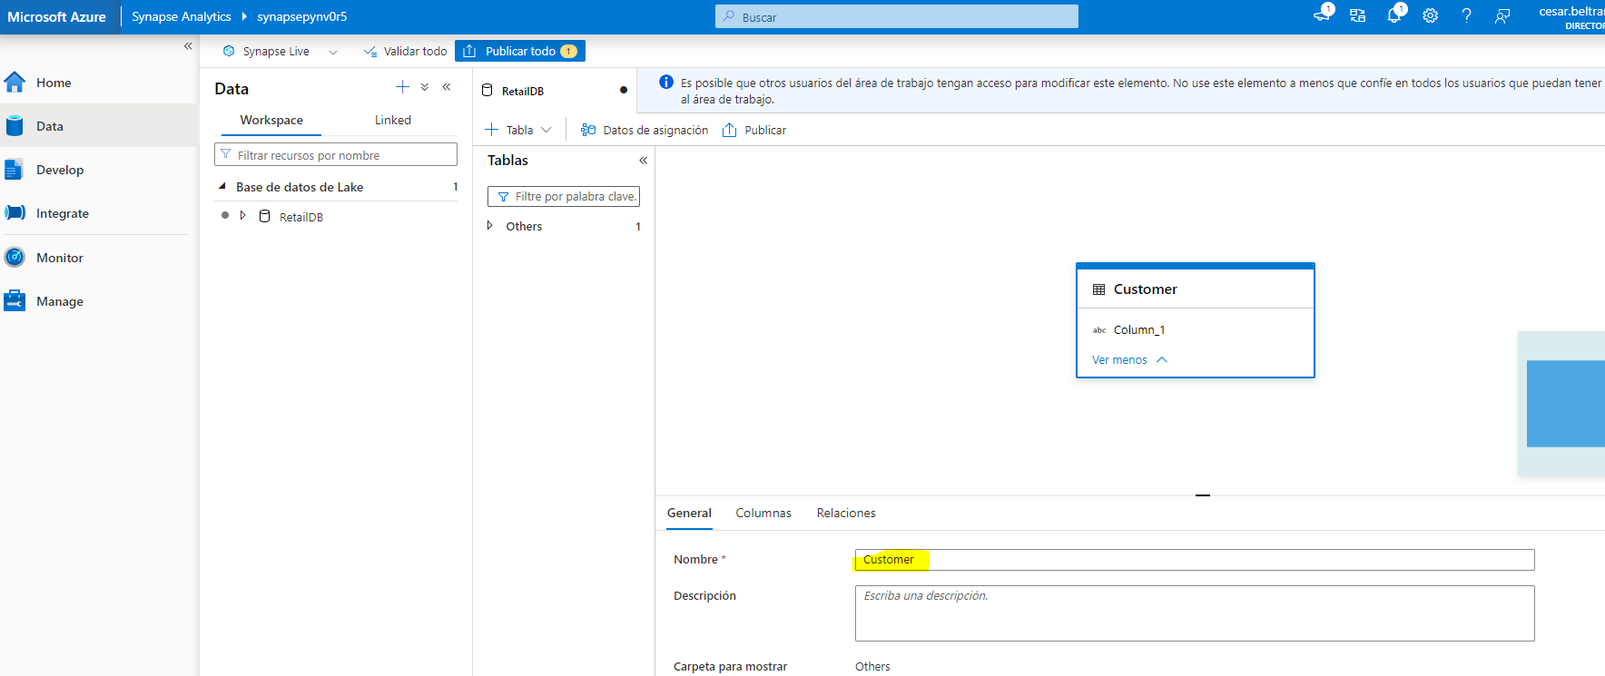

1. Expand the ****Storage settings for table**** section and note that the table will be stored as delimited text in the ****files/RetailDB/Customer**** folder in the default data lake store for your Synapse workspace.

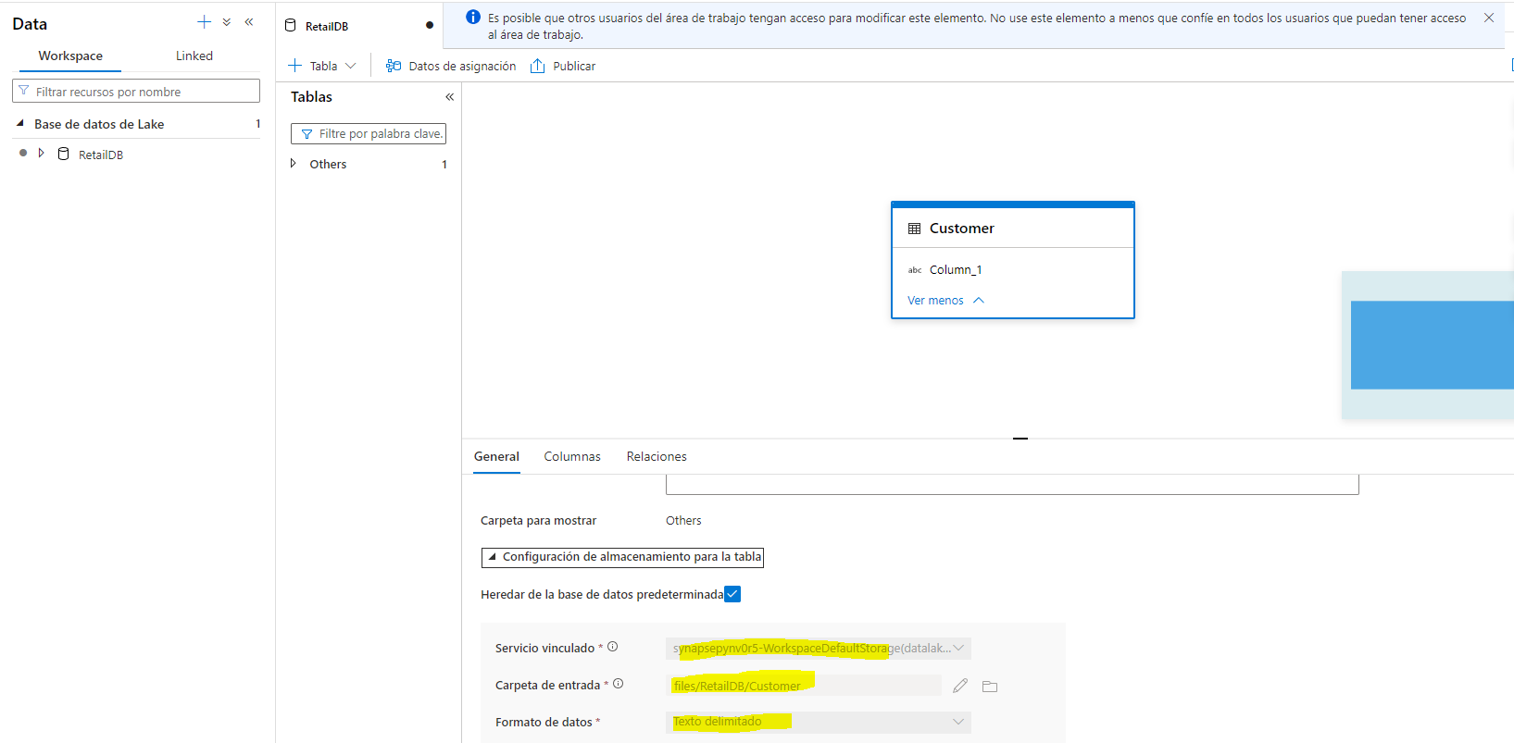

1. On the ****Columns**** tab, note that by default, the table contains one column named ****Column_1****. Edit the column definition to match the following properties:

| Name | Keys | Description | Nullability | Data type | Format / Length |
| --- | --- | --- | --- | --- | --- |
| CustomerId | PK 🗹 | Unique customer ID | 🗆 | long |  |

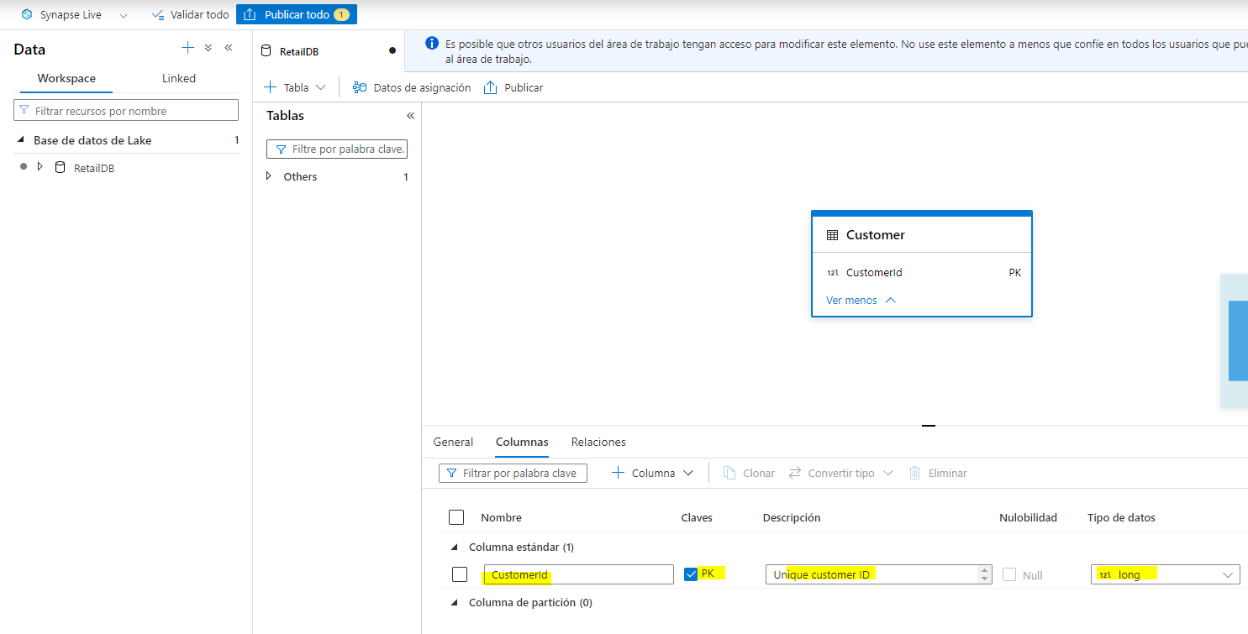

1. In the ****+ Column**** list, select ****New column****, and modify the new column definition to add a ****FirstName**** column to the table as follows:

| Name | Keys | Description | Nullability | Data type | Format / Length |
| --- | --- | --- | --- | --- | --- |
| CustomerId | PK 🗹 | Unique customer ID | 🗆 | long |  |
| ****FirstName**** | ****PK 🗆**** | ****Customer first name**** | ****🗆**** | ****string**** | ****256**** |

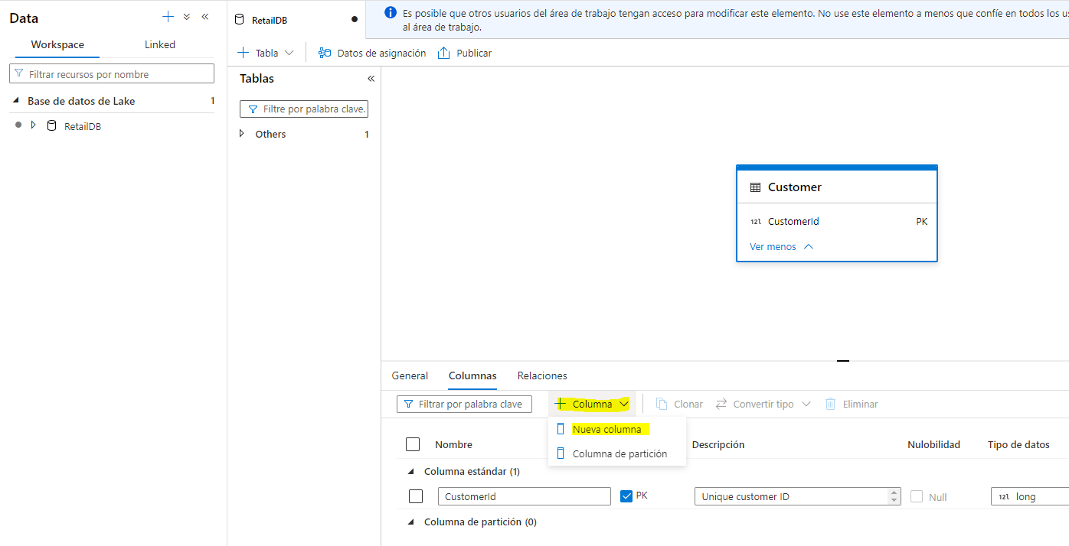

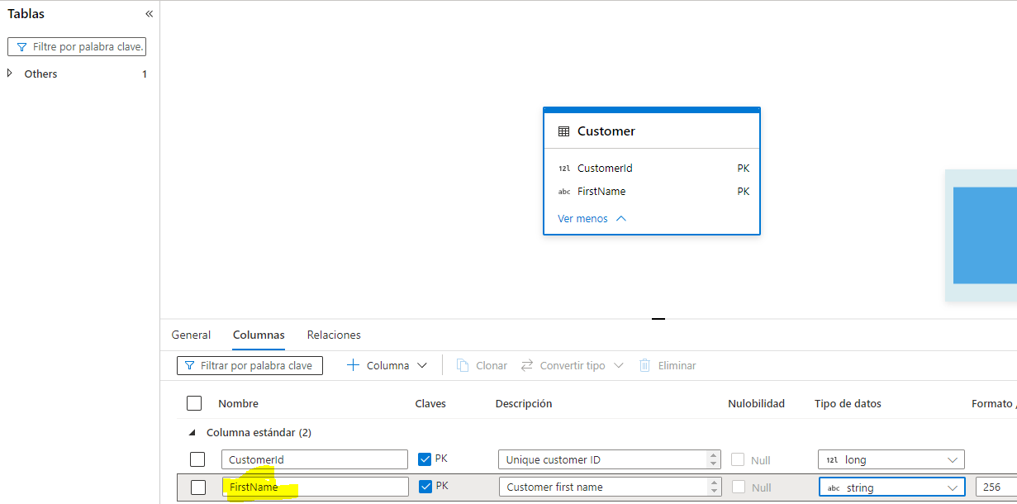

1. Add more new columns until the table definition looks like this:

| Name | Keys | Description | Nullability | Data type | Format / Length |
| --- | --- | --- | --- | --- | --- |
| CustomerId | PK 🗹 | Unique customer ID | 🗆 | long |  |
| FirstName | PK 🗆 | Customer first name | 🗆 | string | 256 |
| LastName | PK 🗆 | Customer last name | 🗹 | string | 256 |
| EmailAddress | PK 🗆 | Customer email | 🗆 | string | 256 |
| Phone | PK 🗆 | Customer phone | 🗹 | string | 256 |

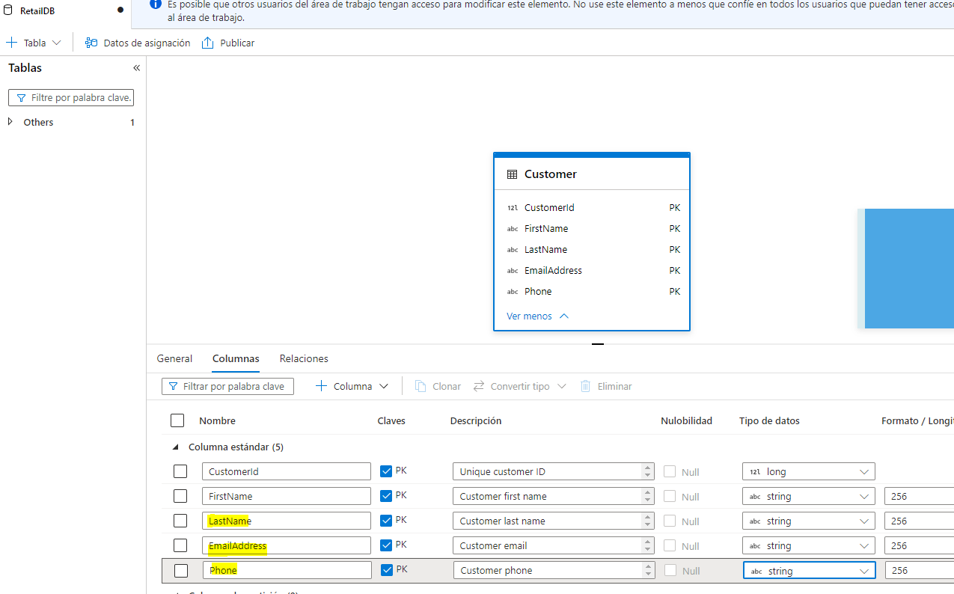

1. When you’ve added all of the columns, publish the database again to save the changes.

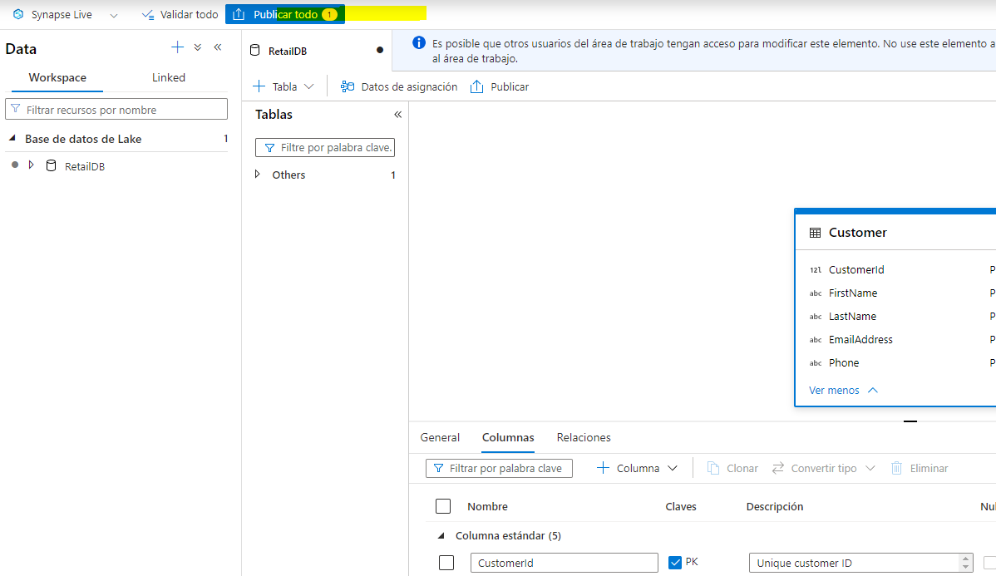

1. In the ****Data**** pane on the left, switch back to the ****Workspace**** tab so you can see the ****RetailDB**** lake database. Then expand it and refresh its ****Tables**** folder to see the newly created ****Customer**** table.

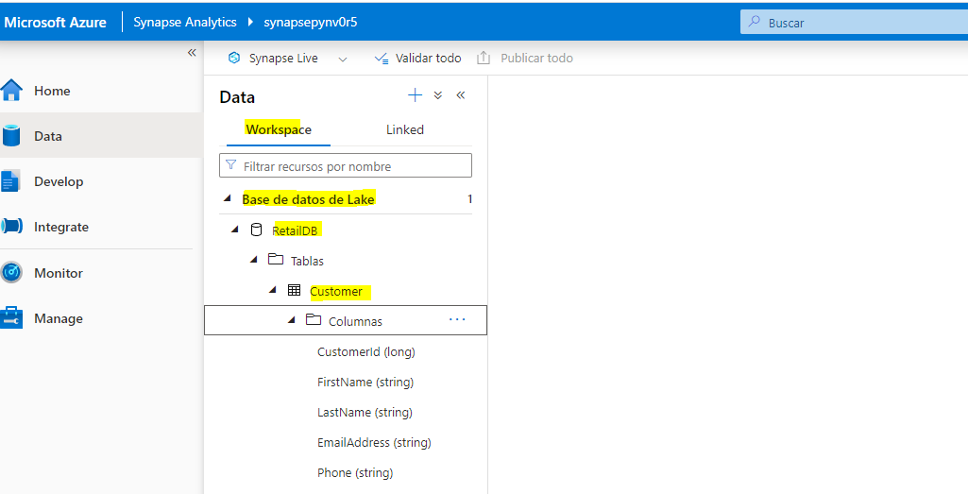

### Load data into the table’s storage path

1. In the main pane, switch back to the ****files**** tab, which contains the file system with the ****RetailDB**** folder. Then open the ****RetailDB**** folder and create a new folder named ****Customer**** in it. This is where the ****Customer**** table will get its data.

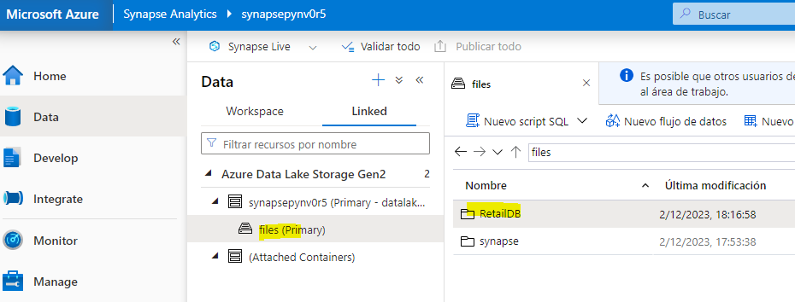

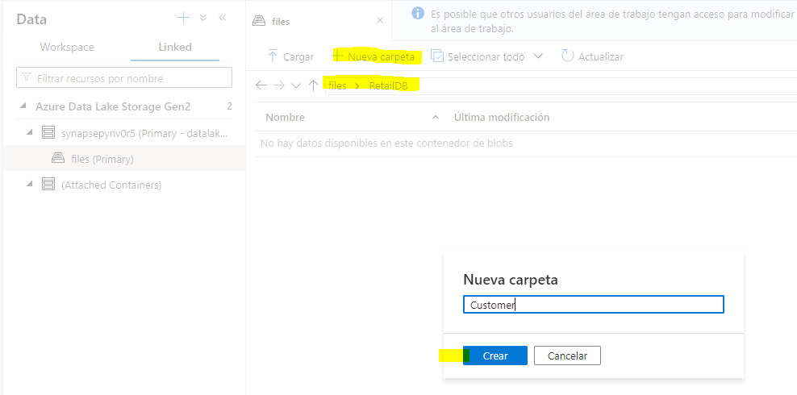

1. Open the new ****Customer**** folder, which should be empty.
2. Download the ****customer.csv**** data file from <https://raw.githubusercontent.com/MicrosoftLearning/dp-203-azure-data-engineer/master/Allfiles/labs/04/data/customer.csv> and save it in a folder on your local computer (it doesn’t matter where). Then in the ****Customer**** folder in Synapse Explorer, use the ****⤒ Upload**** button to upload the ****customer.csv**** file to the ****RetailDB/Customer**** folder in your data lake.

****Note****: In a real production scenario, you would probably create a pipeline to ingest data into the folder for the table data. We’re uploading it directly in the Synapse Studio user interface in this exercise for expediency.

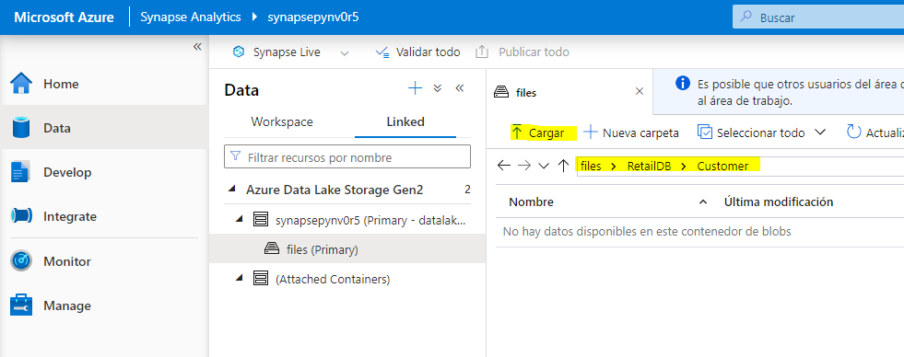

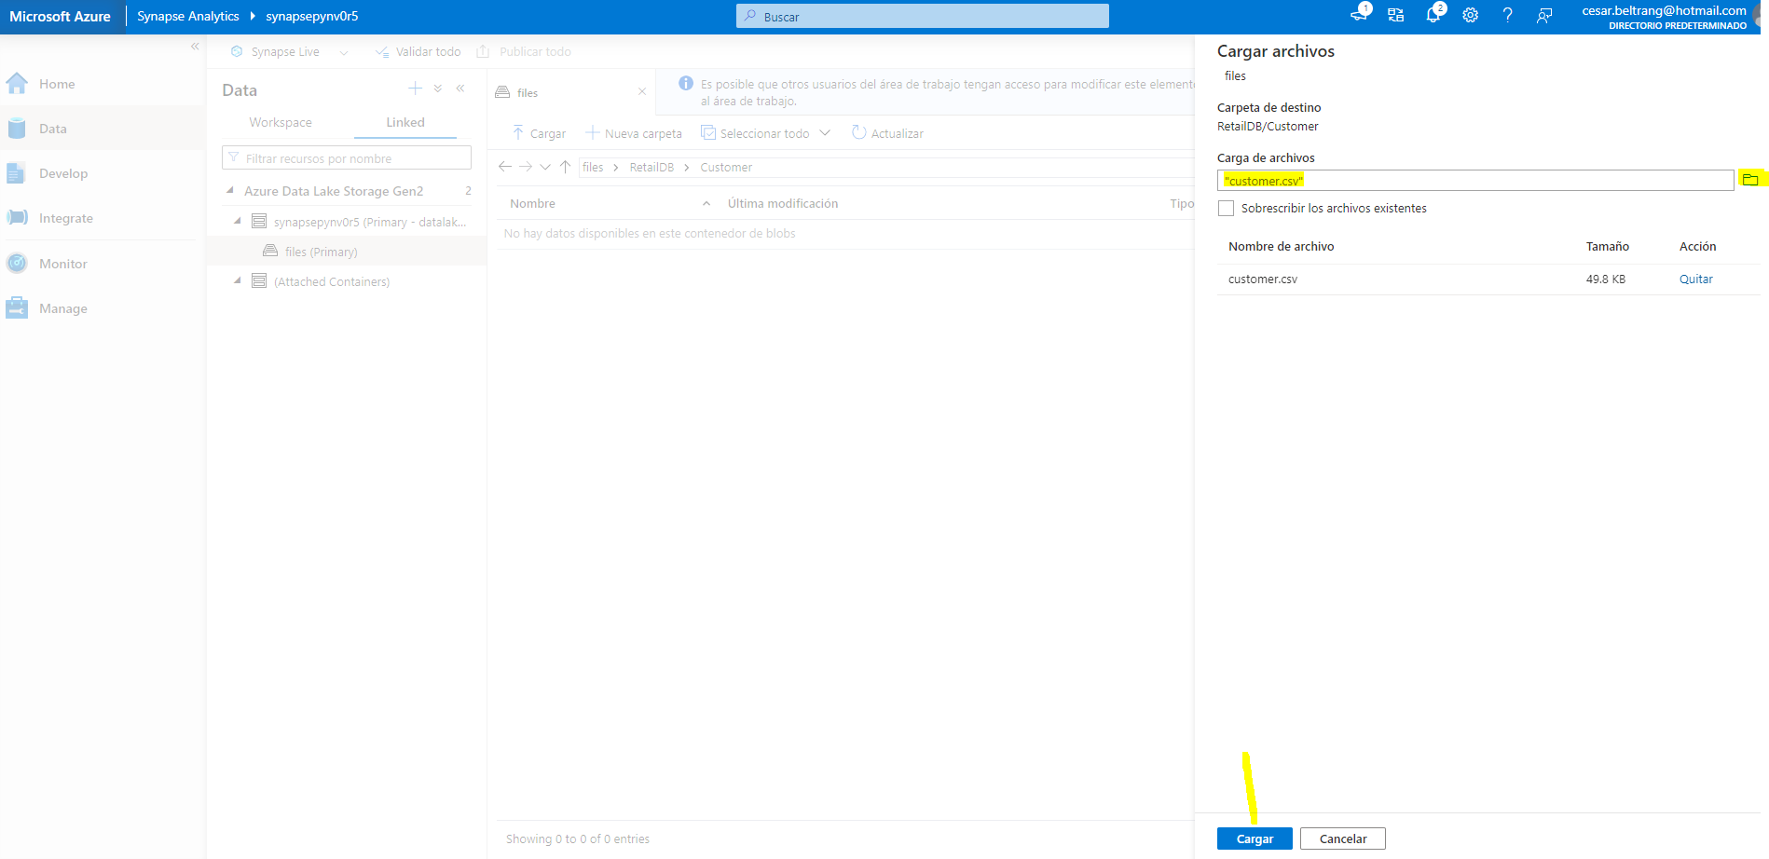

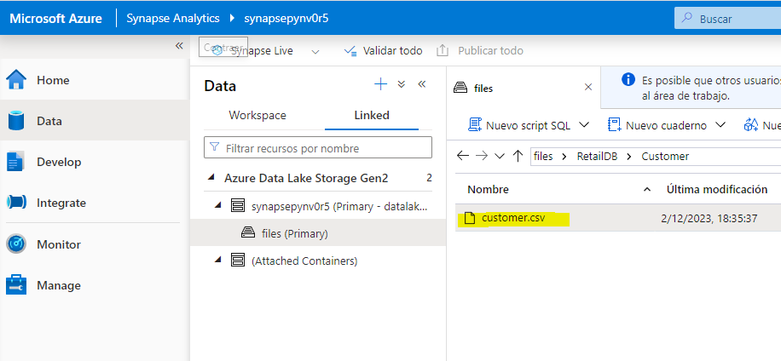

1. In the ****Data**** pane on the left, on the ****Workspace**** tab, in the ****…**** menu for the ****Customer**** table, select ****New SQL script**** > ****Select TOP 100 rows****. Then, in the new ****SQL script 1**** pane that has opened, ensure that the ****Built-in**** SQL pool is connected, and use the ****▷ Run**** button to run the SQL code. The results should include first 100 rows from the ****Customer**** table, based on the data stored in the underlying folder in the data lake.

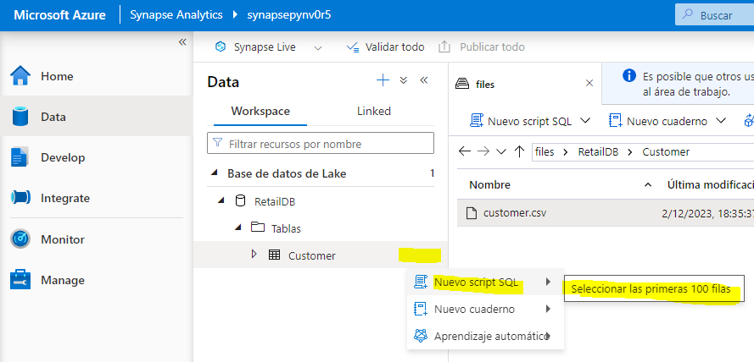

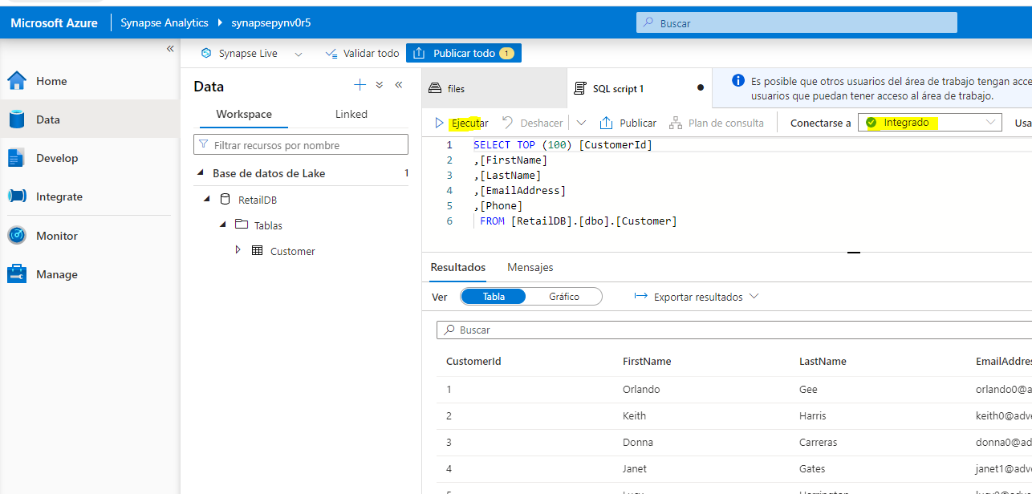

1. Close the ****SQL script 1**** tab, discarding your changes.

## Create a table from a database template

As you’ve seen, you can create the tables you need in your lake database from scratch. However, Azure Synapse Analytics also provides numerous database templates based on common database workloads and entities that you can use as a starting point for your database schema.

### Define the table schema

1. In the main pane, switch back to the ****RetailDB**** pane, which contains your database schema (currently containing only the ****Customer**** table).

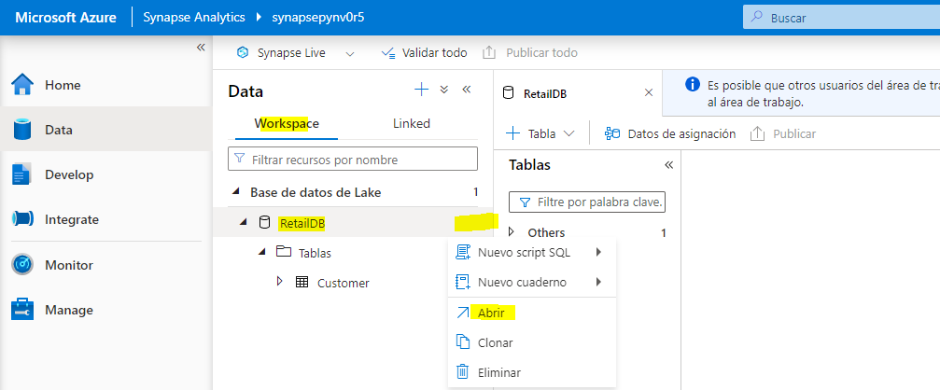

1. In the ****+ Table**** menu, select ****From template****. Then in the ****Add from template**** page, select ****Retail**** and click ****Continue****.

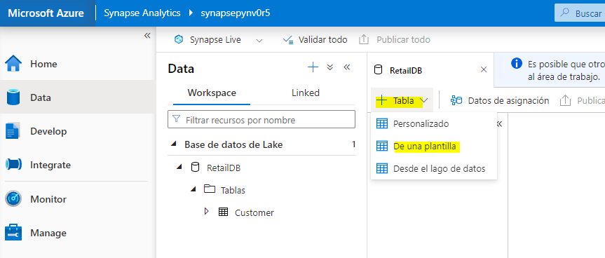

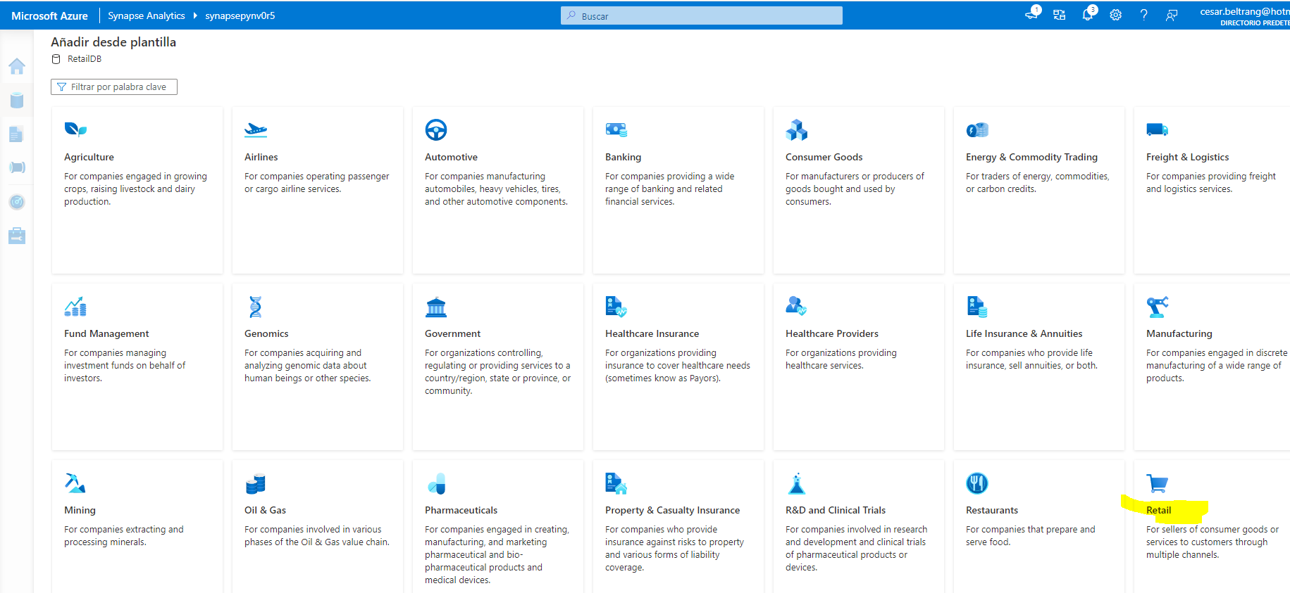

1. In the ****Add from template (Retail)**** page, wait for the table list to populate, and then expand ****Product**** and select ****RetailProduct****. Then click ****Add****. This adds a new table based on the ****RetailProduct**** template to your database.

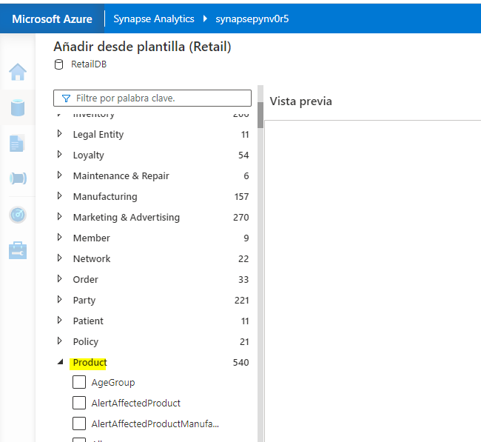

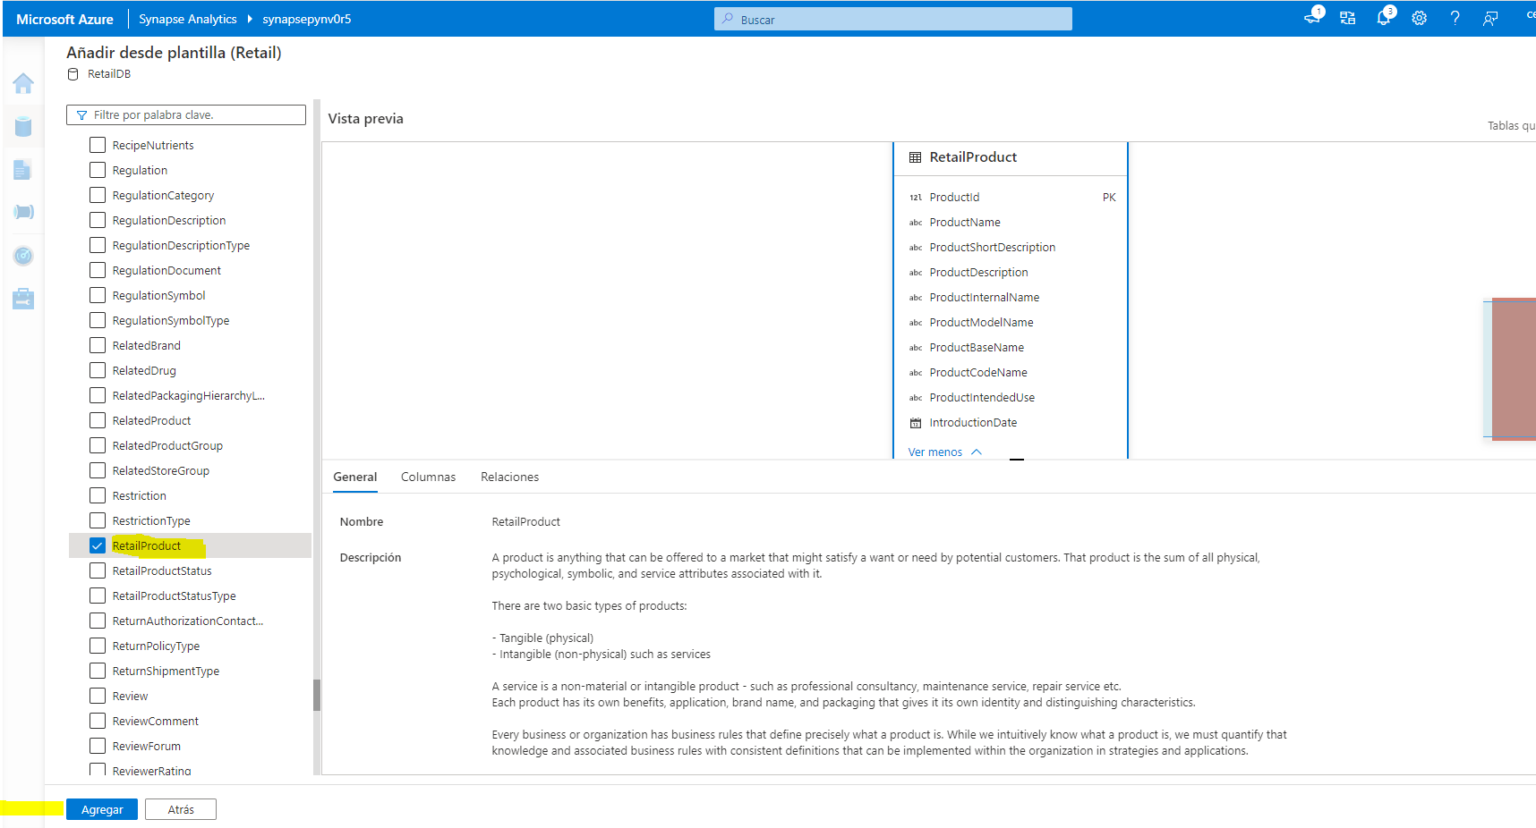

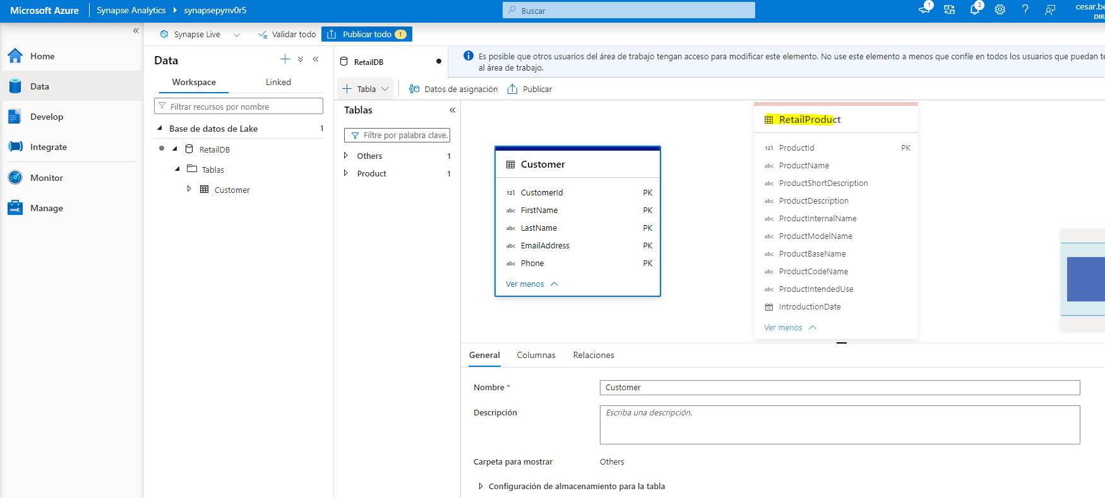

Publicar

1. In the ****RetailDB**** pane, select the new ****RetailProduct**** table. Then, in the pane beneath the design canvas, on the ****General**** tab, change the name to ****Product**** and verify that the storage settings for the table specify the input folder ****files/RetailDB/Product****.

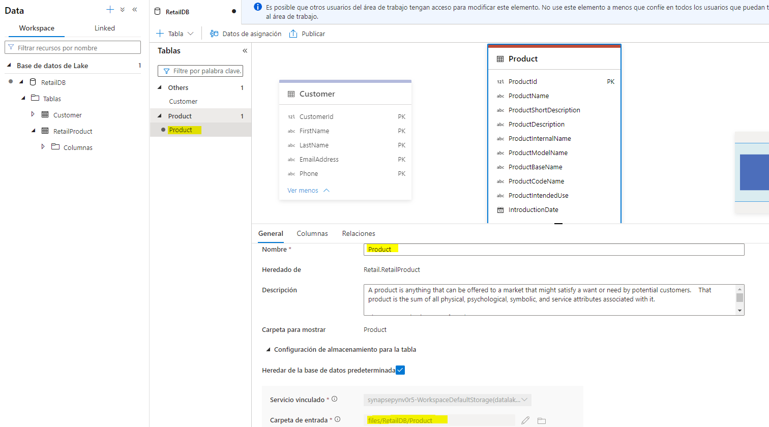

1. On the ****Columns**** tab for the ****Product**** table, note that the table already includes a large number of columns inherited from the template. There are more columns than required for this table, so you’ll need to remove some.
2. Select the checkbox next to ****Name**** to select all of the columns, and then unselect the following columns (which you need to retain):

* ProductId
* ProductName
* IntroductionDate
* ActualAbandonmentDate
* ProductGrossWeight
* ItemSku

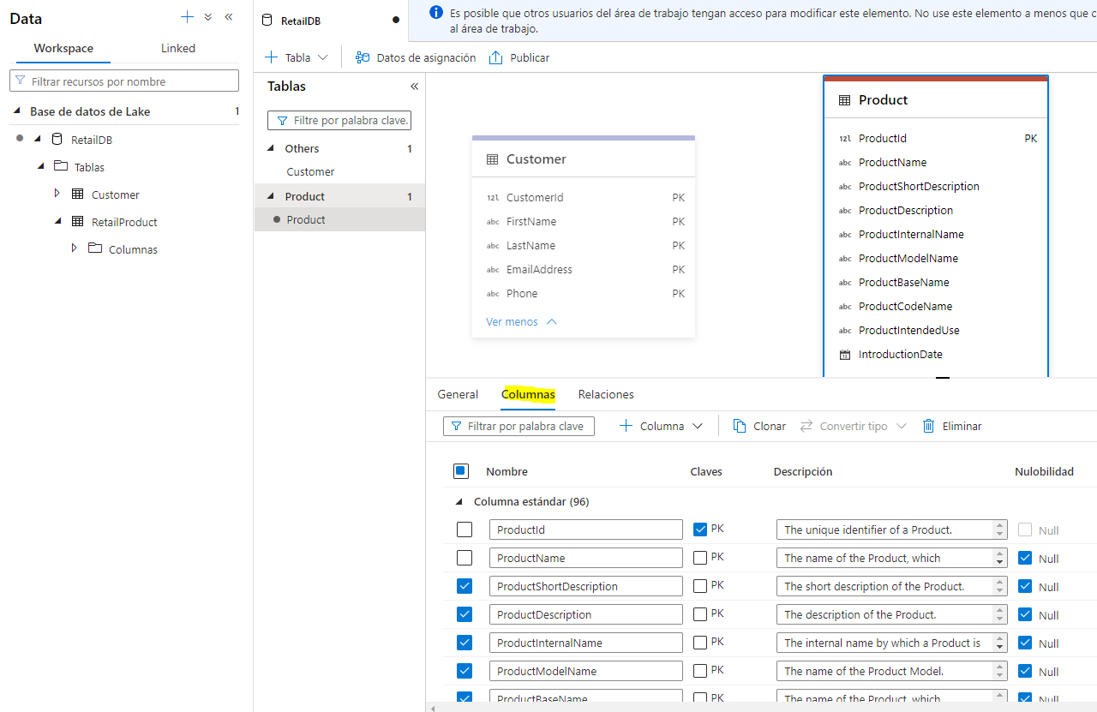

1. On the toolbar in the ****Columns**** pane, select ****Delete**** to remove the selected columns. This should leave you with the following columns

| Name | Keys | Description | Nullability | Data type | Format / Length |
| --- | --- | --- | --- | --- | --- |
| ProductId | PK 🗹 | The unique identifier of a Product. | 🗆 | long |  |
| ProductName | PK 🗆 | The name of the Product… | 🗹 | string | 128 |
| IntroductionDate | PK 🗆 | The date that the Product was introduced for sale. | 🗹 | date | YYYY-MM-DD |
| ActualAbandonmentDate | PK 🗆 | The actual date that the marketing of the product was discontinued… | 🗹 | date | YYY-MM-DD |
| ProductGrossWeight | PK 🗆 | The gross product weight. | 🗹 | decimal | 18,8 |
| ItemSku | PK 🗆 | The Stock Keeping Unit identifier… | 🗹 | string | 20 |

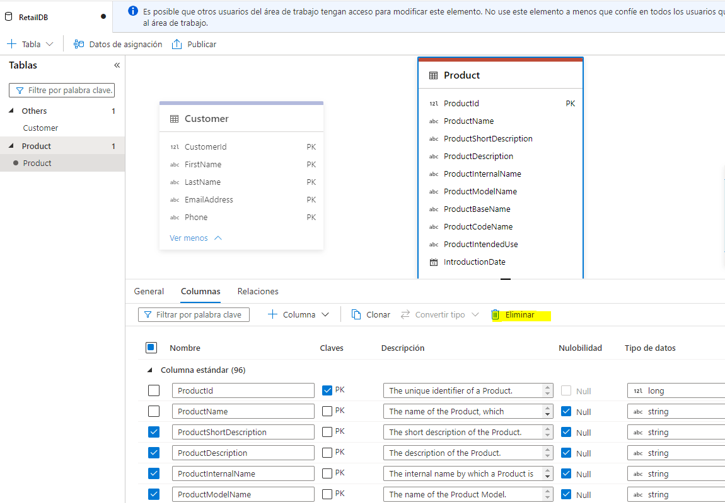

1. Add a new column named ****ListPrice**** to the table as shown here:

| Name | Keys | Description | Nullability | Data type | Format / Length |
| --- | --- | --- | --- | --- | --- |
| ProductId | PK 🗹 | The unique identifier of a Product. | 🗆 | long |  |
| ProductName | PK 🗆 | The name of the Product… | 🗹 | string | 128 |
| IntroductionDate | PK 🗆 | The date that the Product was introduced for sale. | 🗹 | date | YYYY-MM-DD |
| ActualAbandonmentDate | PK 🗆 | The actual date that the marketing of the product was discontinued… | 🗹 | date | YYY-MM-DD |
| ProductGrossWeight | PK 🗆 | The gross product weight. | 🗹 | decimal | 18,8 |
| ItemSku | PK 🗆 | The Stock Keeping Unit identifier… | 🗹 | string | 20 |
| ****ListPrice**** | ****PK 🗆**** | ****The product price.**** | ****🗆**** | ****decimal**** | ****18,2**** |

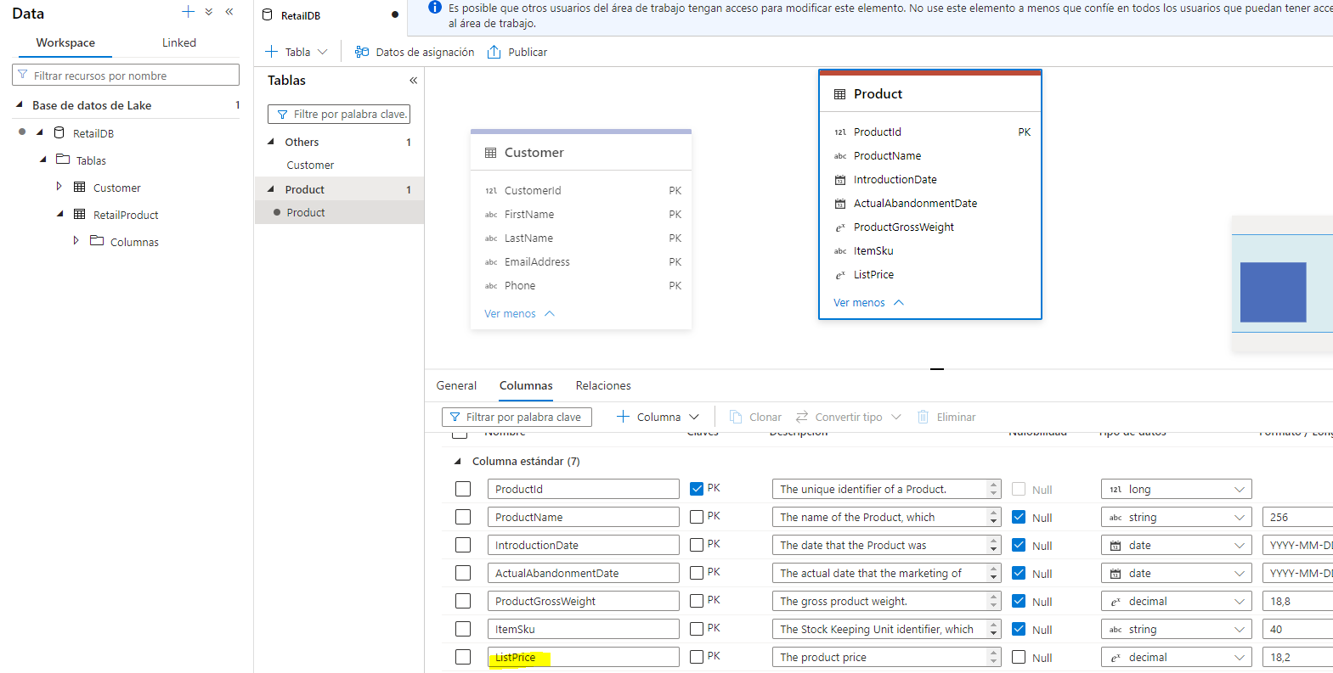

1. When you’ve modified the columns as shown above, publish the database again to save the changes.
2. In the ****Data**** pane on the left, switch back to the ****Workspace**** tab so you can see the ****RetailDB**** lake database. Then use the ****…**** menu for its ****Tables**** folder to refresh the view and see the newly created ****Product**** table.

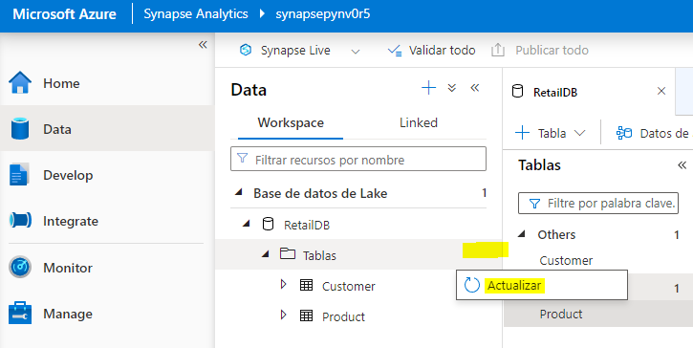

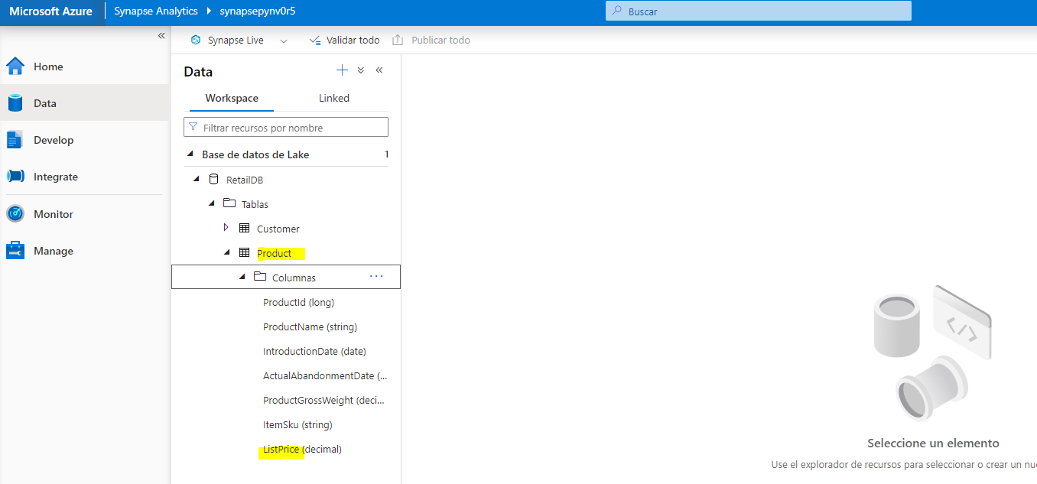

### Load data into the table’s storage path

1. In the main pane, switch back to the ****files**** tab, which contains the file system, and navigate to the ****files/RetailDB**** folder, which currently contains the ****Customer**** folder for the table you created previously.
2. In the ****RetailDB**** folder, create a new folder named ****Product****. This is where the ****Product**** table will get its data.

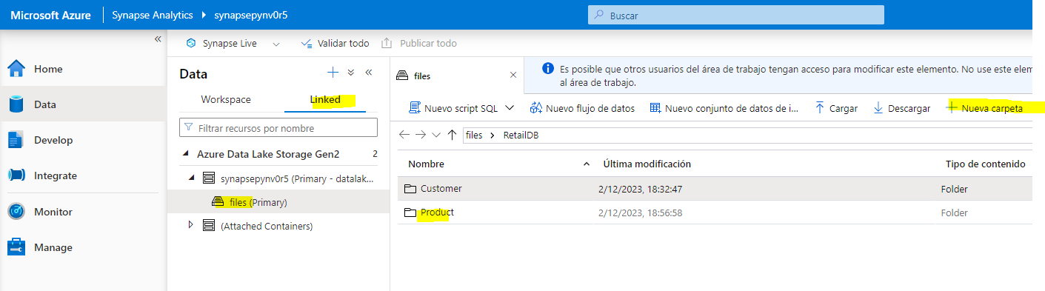

1. Open the new ****Product**** folder, which should be empty.
2. Download the ****product.csv**** data file from <https://raw.githubusercontent.com/MicrosoftLearning/dp-203-azure-data-engineer/master/Allfiles/labs/04/data/product.csv> and save it in a folder on your local computer (it doesn’t matter where). Then in the ****Product**** folder in Synapse Explorer, use the ****⤒ Upload**** button to upload the ****product.csv**** file to the ****RetailDB/Product**** folder in your data lake.

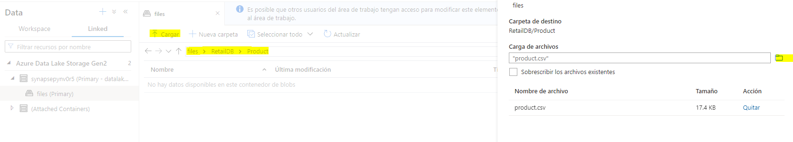

1. In the ****Data**** pane on the left, on the ****Workspace**** tab, in the ****…**** menu for the ****Product**** table, select ****New SQL script**** > ****Select TOP 100 rows****. Then, in the new ****SQL script 1**** pane that has opened, ensure that the ****Built-in**** SQL pool is connected, and use the ****▷ Run**** button to run the SQL code. The results should include first 100 rows from the ****Product**** table, based on the data stored in the underlying folder in the data lake.

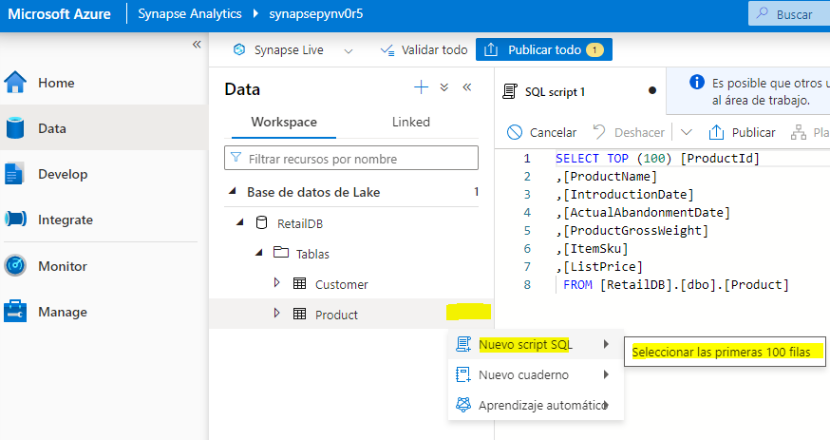

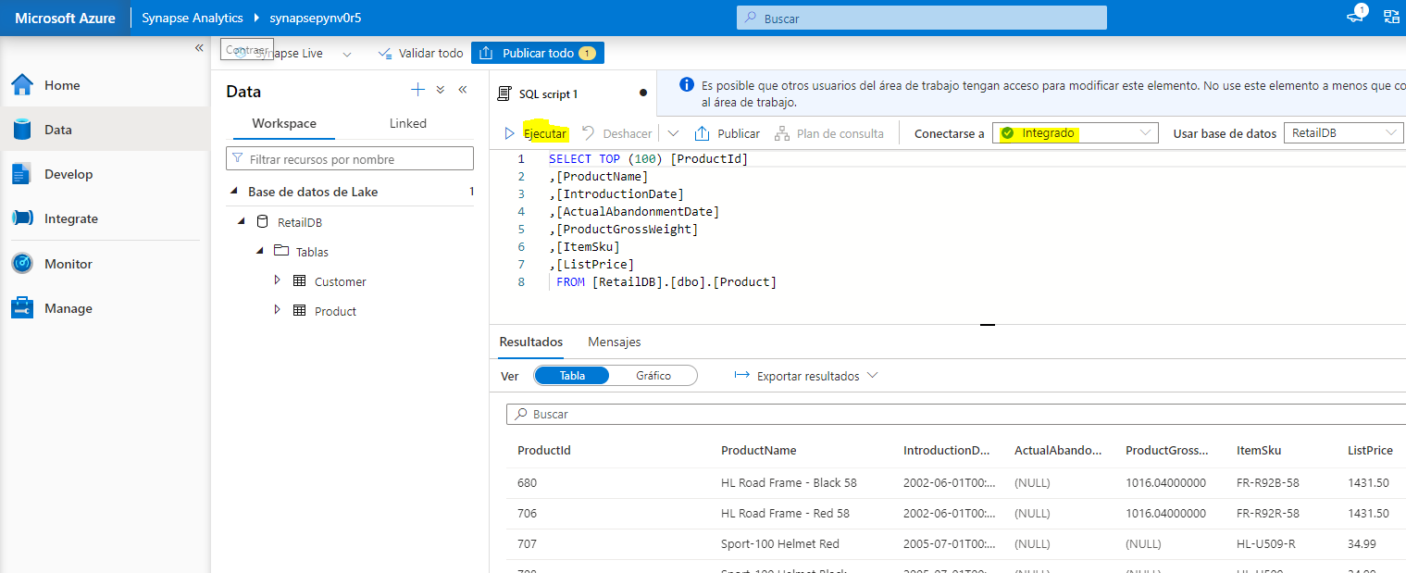

1. Close the ****SQL script 1**** tab, discarding your changes.

## Create a table from existing data

So far, you’ve created tables and then populated them with data. In some cases, you may already have data in a data lake from which you want to derive a table.

### Upload data

1. In the main pane, switch back to the ****files**** tab, which contains the file system, and navigate to the ****files/RetailDB**** folder, which currently contains the ****Customer**** and ****Product**** folders for the tables you created previously.

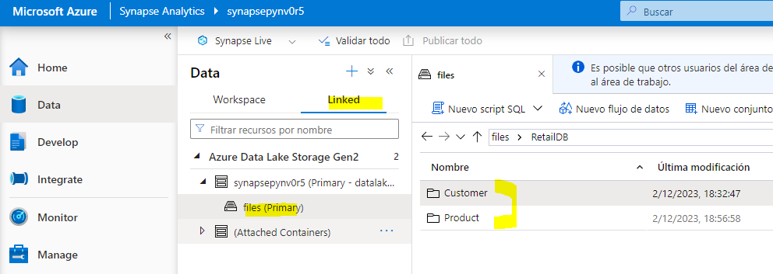

1. In the ****RetailDB**** folder, create a new folder named ****SalesOrder****.

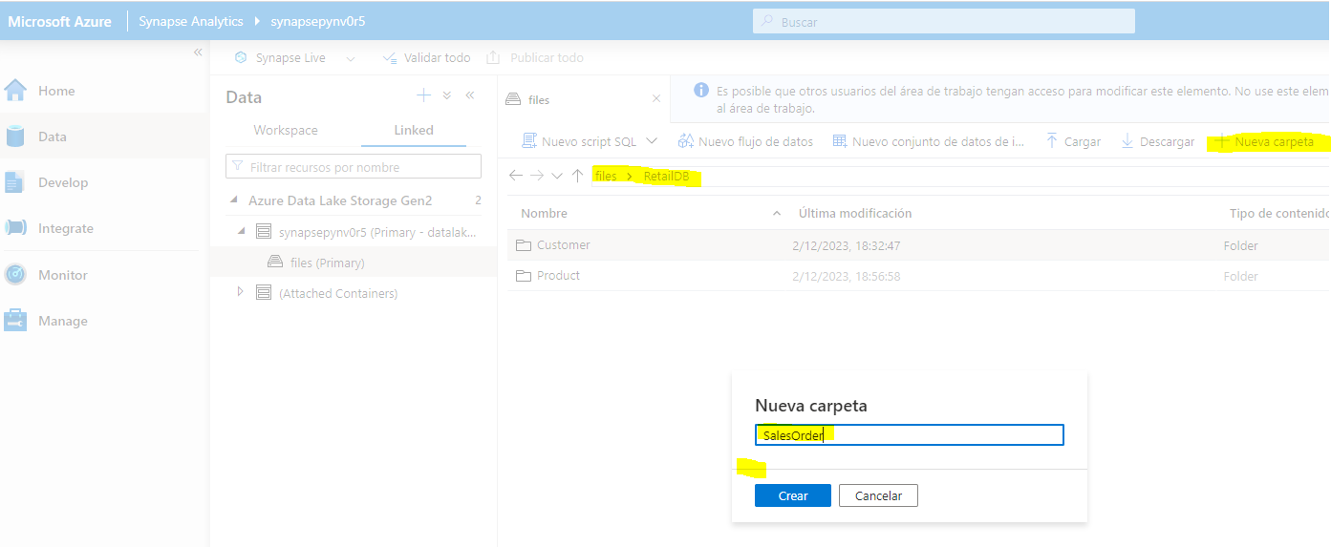

1. Open the new ****SalesOrder**** folder, which should be empty.
2. Download the ****salesorder.csv**** data file from <https://raw.githubusercontent.com/MicrosoftLearning/dp-203-azure-data-engineer/master/Allfiles/labs/04/data/salesorder.csv> and save it in a folder on your local computer (it doesn’t matter where). Then in the ****SalesOrder**** folder in Synapse Explorer, use the ****⤒ Upload**** button to upload the ****salesorder.csv**** file to the ****RetailDB/SalesOrder**** folder in your data lake.

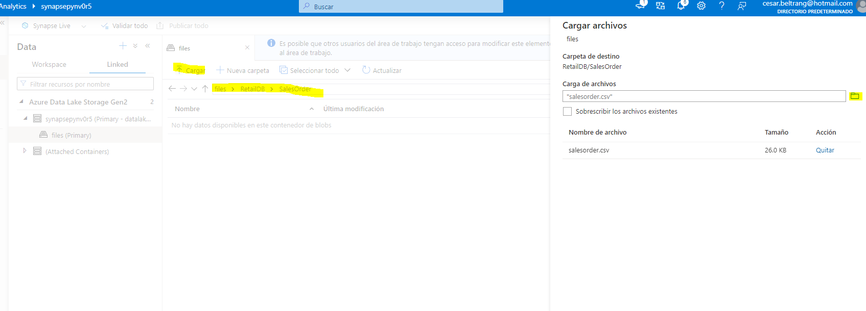

### Create a table

1. In the main pane, switch back to the ****RetailDB**** pane, which contains your database schema (currently containing the ****Customer**** and ****Product**** tables).

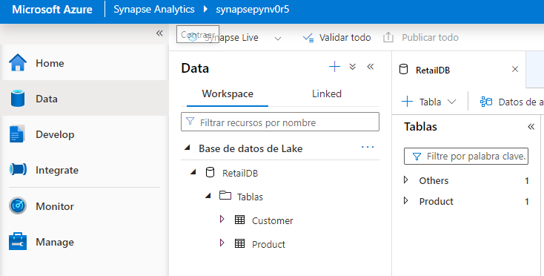

1. In the ****+ Table**** menu, select ****From data lake****. Then in the ****Create external table from data lake**** pane, specify the following options:

* ****External table name****: SalesOrder
* ****Linked service****: Select ****synapse**xxxxxxx**-WorkspaceDefautStorage(datalake**xxxxxxx**)****
* ****Input file of folder****: files/RetailDB/SalesOrder

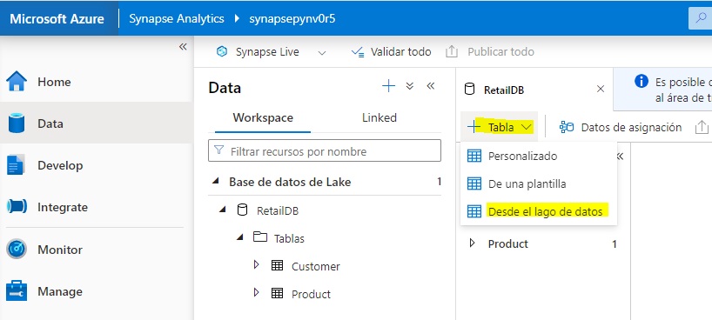

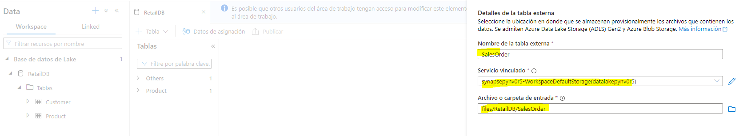

1. Continue to the next page and then create the table with the following options:

* ****File type****: CSV
* ****Field terminator****: Default (comma ,)
* ****First row****: Leave infer column names unselected.
* ****String delimiter****: Default (Empty string)
* ****Use default type****: Default type (true,false)
* ****Max string length****: 4000

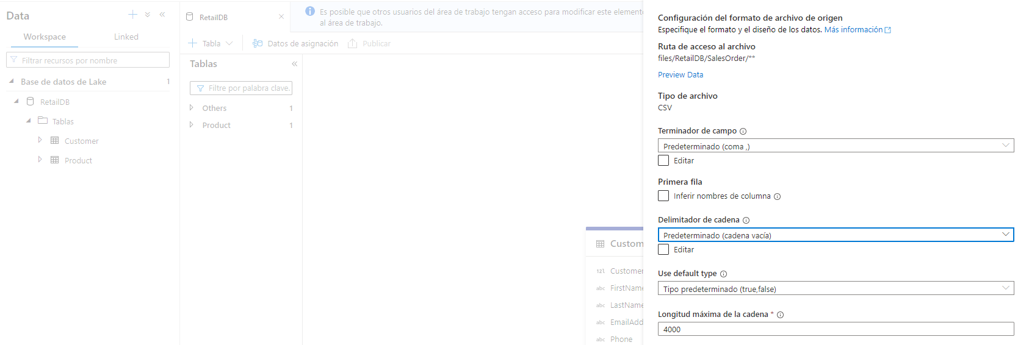

1. When the table has been created, note that it includes columns named ****C1****, ****C2****, and so on and that the data types have been inferred from the data in the folder. Modify the column definitions as follows:

| Name | Keys | Description | Nullability | Data type | Format / Length |
| --- | --- | --- | --- | --- | --- |
| SalesOrderId | PK 🗹 | The unique identifier of an order. | 🗆 | long |  |
| OrderDate | PK 🗆 | The date of the order. | 🗆 | timestamp | yyyy-MM-dd |
| LineItemId | PK 🗹 | The ID of an individual line item. | 🗆 | long |  |
| CustomerId | PK 🗆 | The customer. | 🗆 | long |  |
| ProductId | PK 🗆 | The product. | 🗆 | long |  |
| Quantity | PK 🗆 | The order quantity. | 🗆 | long |  |

****Note****: The table contains a record for each individual item ordered, and includes a composite primary key comprised of ****SalesOrderId**** and ****LineItemId****.

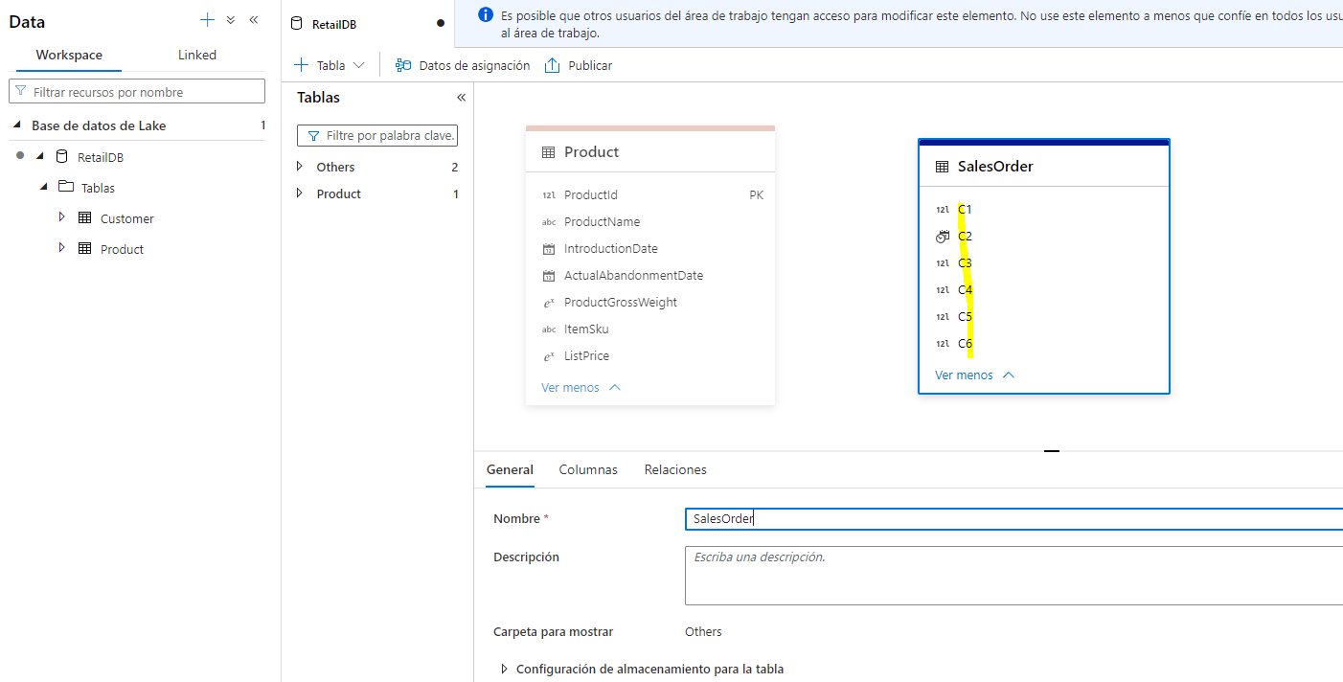

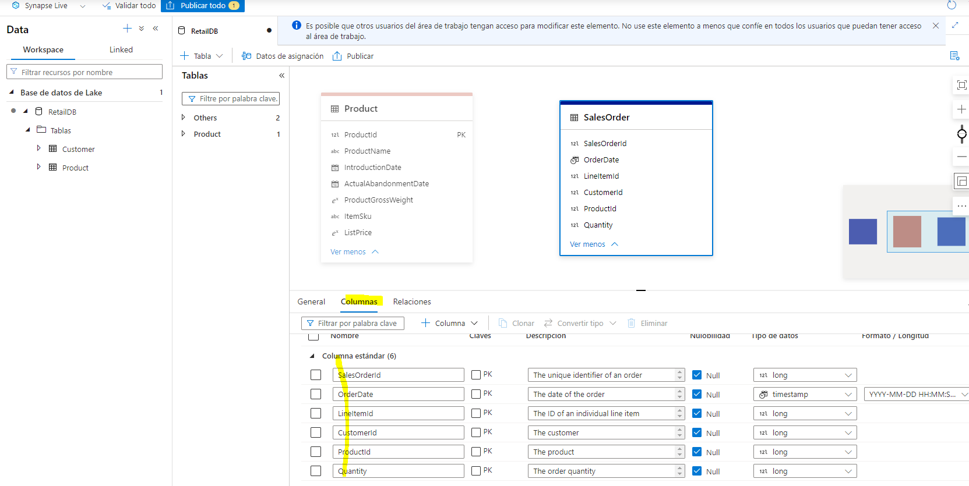

1. On the ****Relationships**** tab for the ****SalesOrder**** table, in the ****+ Relationship**** list, select ****To table****, and then define the following relationship:

| From table | From column | To table | To column |
| --- | --- | --- | --- |
| Customer | CustomerId | SalesOrder | CustomerId |

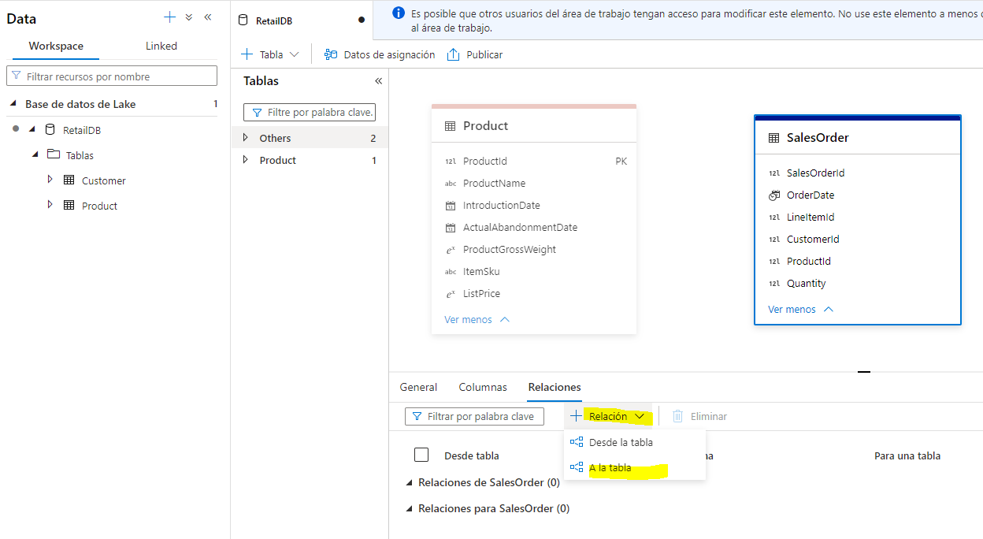

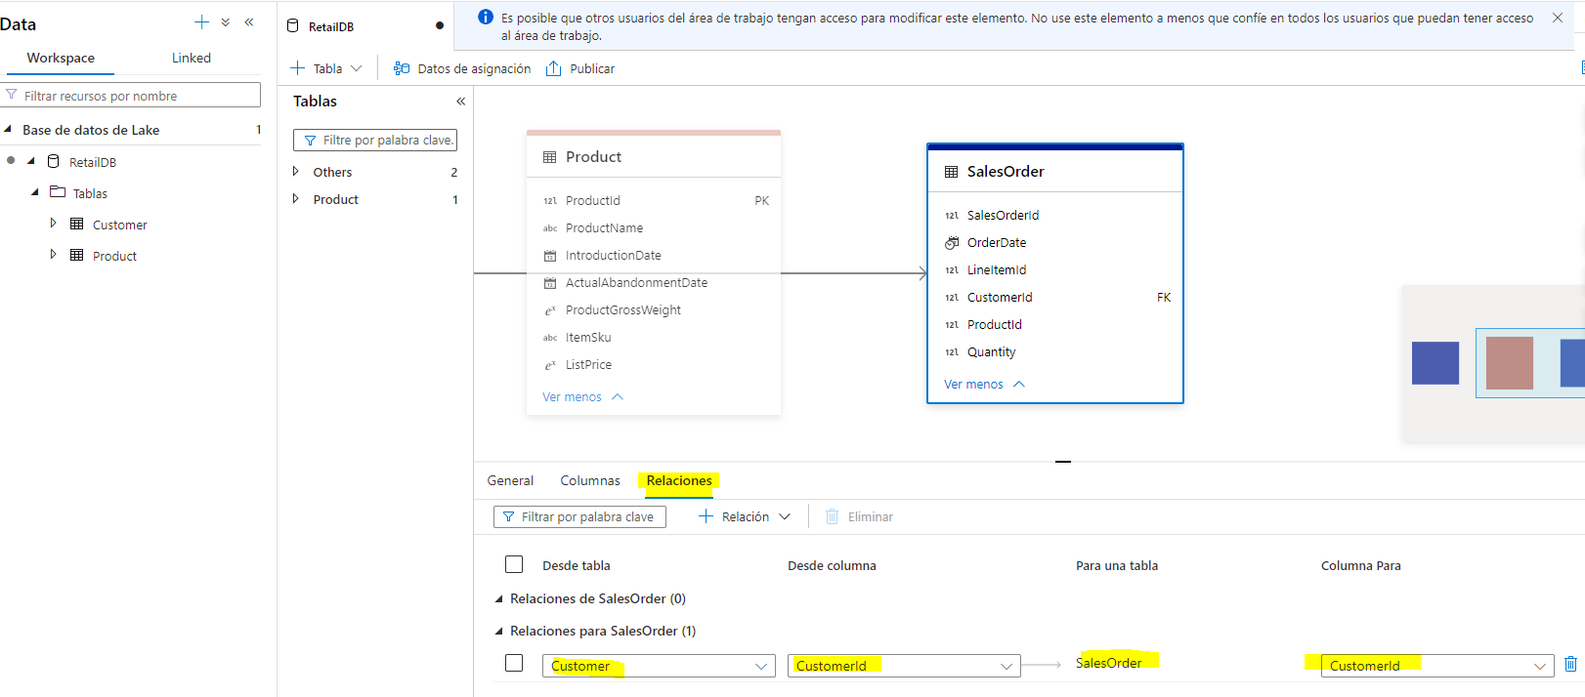

1. Add a second To table relationship with the following settings:

| From table | From column | To table | To column |
| --- | --- | --- | --- |
| Product | ProductId | SalesOrder | ProductId |

The ability to define relationships between tables helps enforce referential integrity between related data entities. This is a common feature of relational databases that would otherwise be difficult to apply to files in a data lake.

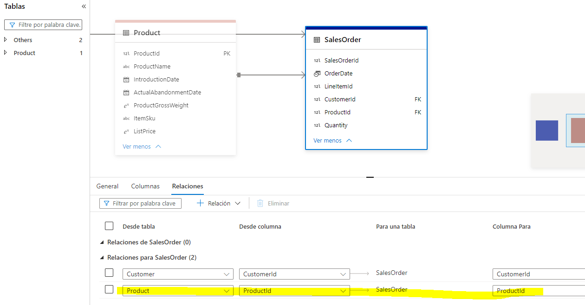

1. Publish the database again to save the changes.
2. In the ****Data**** pane on the left, switch back to the ****Workspace**** tab so you can see the ****RetailDB**** lake database. Then use the ****…**** menu for its ****Tables**** folder to refresh the view and see the newly created ****SalesOrder**** table.

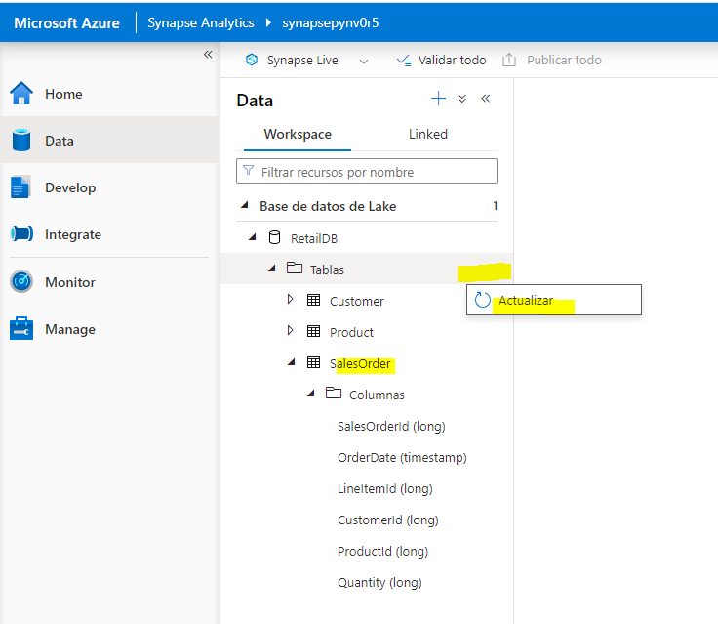

## Work with lake database tables

Now that you have some tables in your database, you can use them to work with the underlying data.

### Query tables using SQL

1. In Synapse Studio, select the ****Develop**** page.
2. In the ****Develop**** pane, in the ****+**** menu, select ****SQL script****.

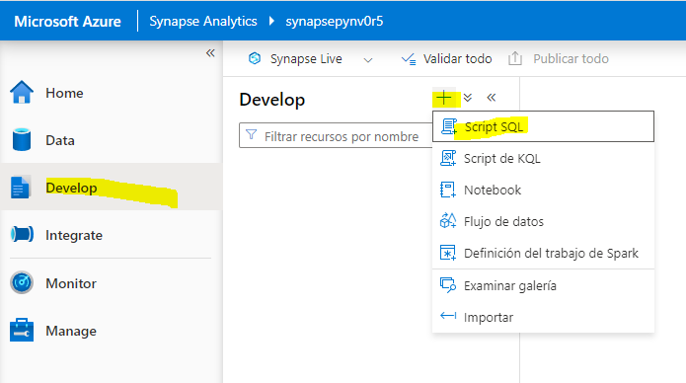

1. In the new ****SQL script 1**** pane, ensure the script is connected to the ****Built-in**** SQL pool and in the ****User database**** list, select ****RetailDB****.
2. Enter the following SQL code:

SELECT o.SalesOrderID, c.EmailAddress, p.ProductName, o.Quantity

FROM SalesOrder AS o

JOIN Customer AS c ON o.CustomerId = c.CustomerId

JOIN Product AS p ON o.ProductId = p.ProductId

1. Use the ****▷ Run**** button to run the SQL code.

The results show order details with customer and product information.

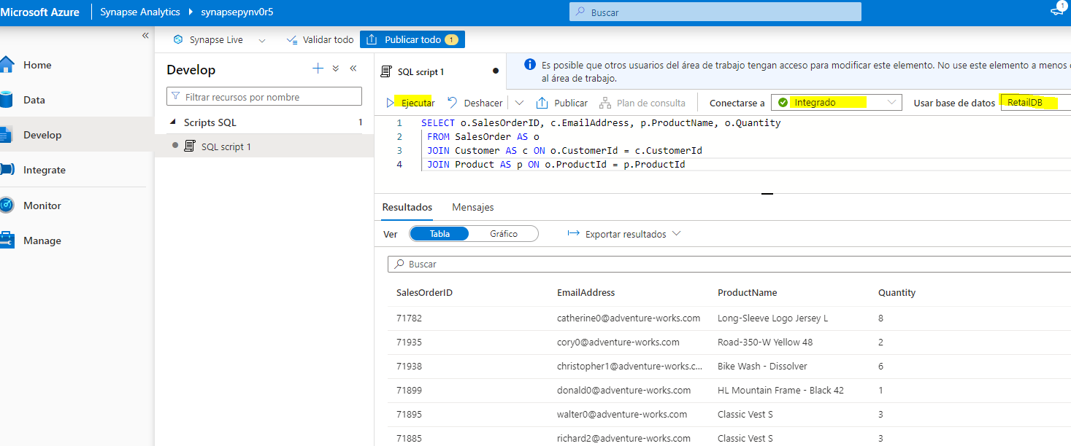

1. Close the ****SQL script 1**** pane, discarding your changes.

### Insert data using Spark

1. In the ****Develop**** pane, in the ****+**** menu, select ****Notebook****.

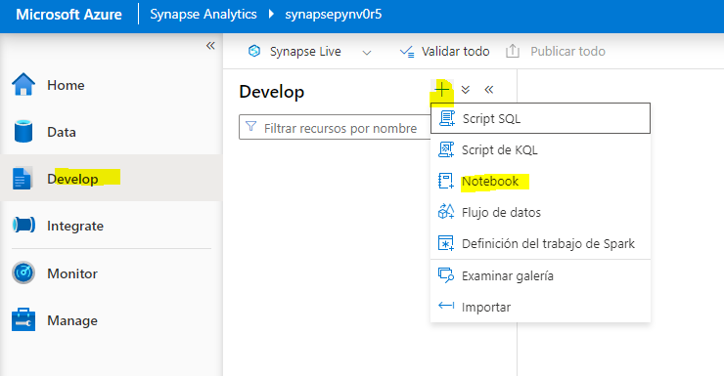

1. In the new ****Notebook 1**** pane, attach the notebook to the ****spark**xxxxxxx**\* Spark pool.

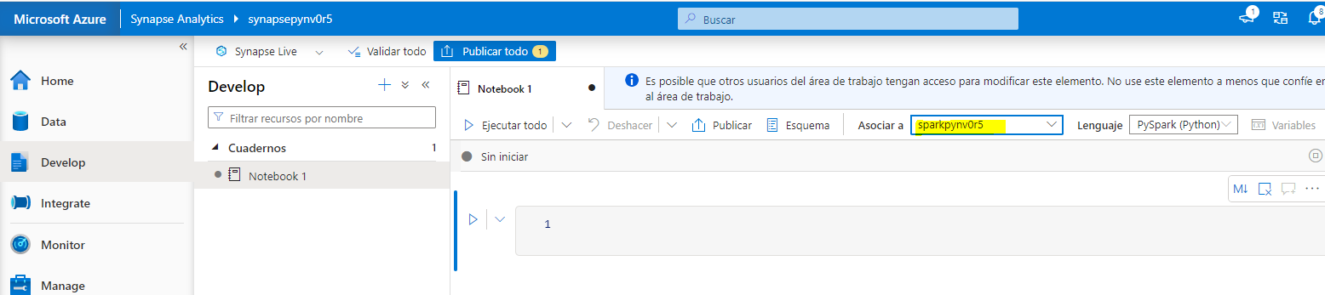

1. Enter the following code in the empty notebook cell:

%%sql

INSERT INTO `RetailDB`.`SalesOrder` VALUES (99999, CAST('2022-01-01' AS TimeStamp), 1, 6, 5, 1)

1. Use the ****▷**** button on the left of the cell to run it and wait for it to finish running. Note that it will take some time to start the Spark pool.

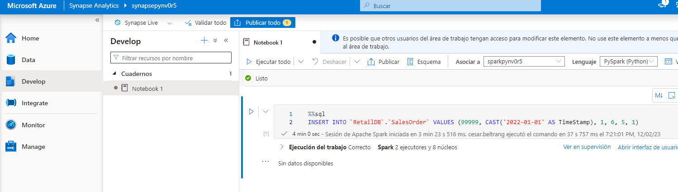

1. Use the ****+ Code**** button to add a new cell to the notebook.

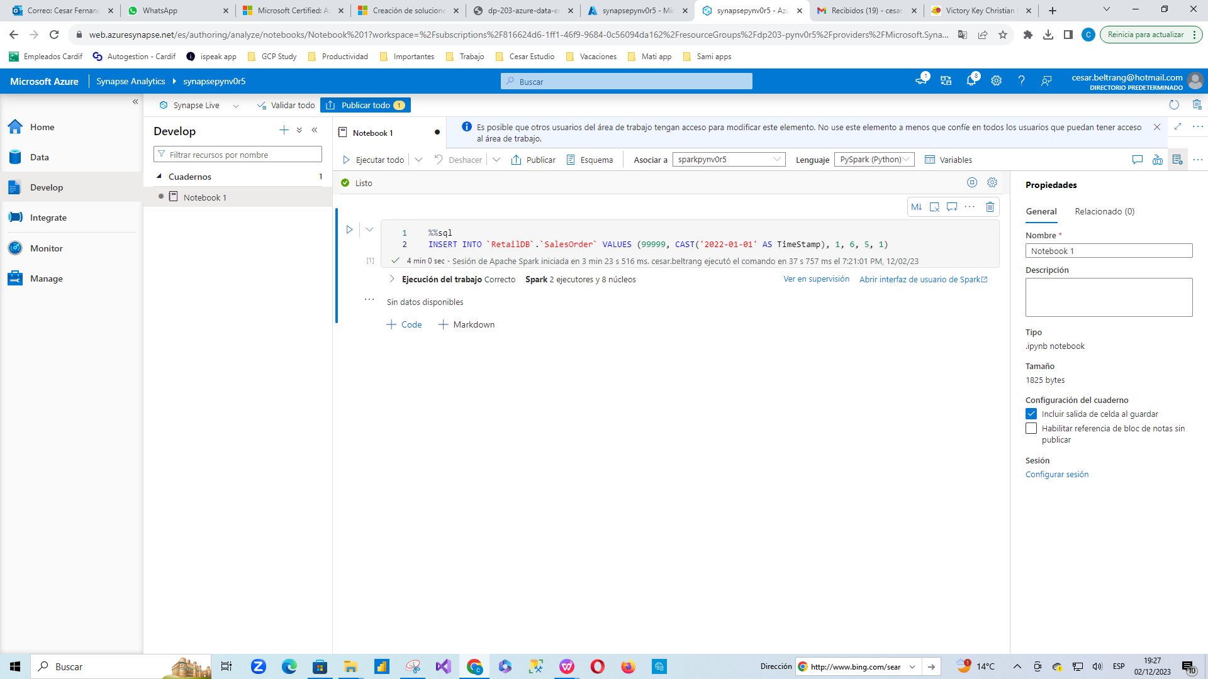

1. Enter the following code in the new cell:

%%sql

SELECT * FROM `RetailDB`.`SalesOrder` WHERE SalesOrderId = 99999

1. Use the ****▷**** button on the left of the cell to run it and verify that a row for sales order 99999 was inserted into the ****SalesOrder**** table.

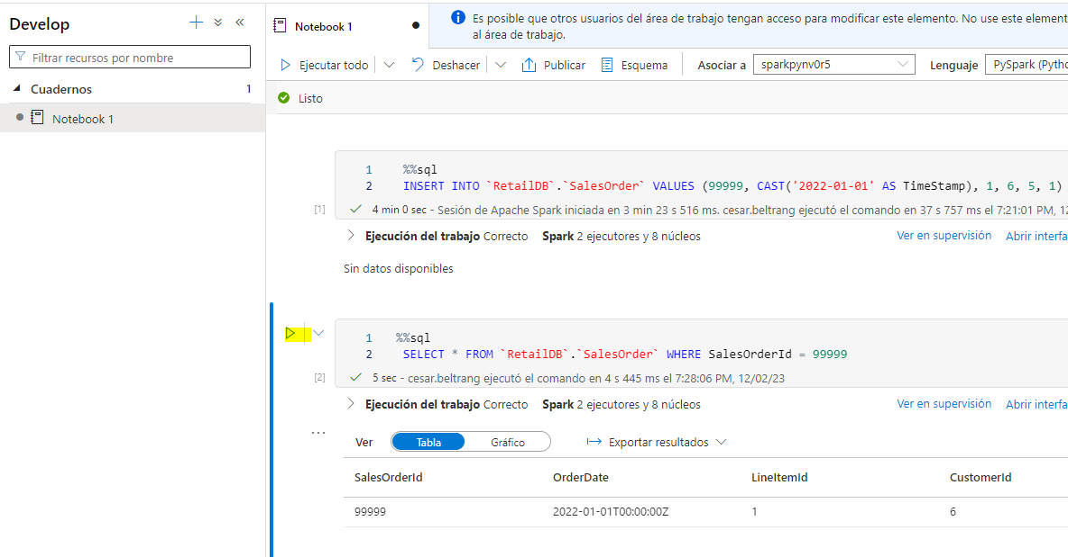

1. Close the ****Notebook 1**** pane, stopping the Spark session and discarding your changes.

## Delete Azure resources

If you’ve finished exploring Azure Synapse Analytics, you should delete the resources you’ve created to avoid unnecessary Azure costs.

1. Close the Synapse Studio browser tab and return to the Azure portal.
2. On the Azure portal, on the ****Home**** page, select ****Resource groups****.
3. Select the ****dp203-**xxxxxxx** resource group for your Synapse Analytics workspace (not the managed resource group), and verify that it contains the Synapse workspace, storage account, and Spark pool for your workspace.
4. At the top of the ****Overview**** page for your resource group, select ****Delete resource group****.

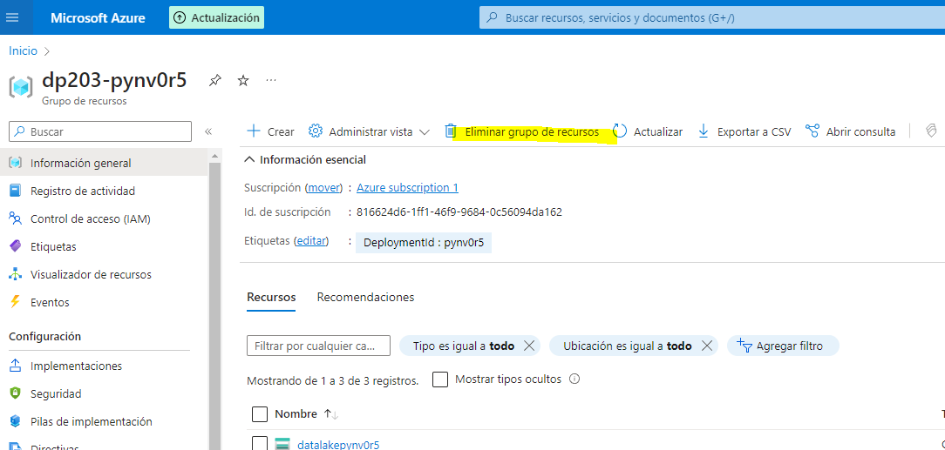

1. Enter the ****dp203-**xxxxxxx** resource group name to confirm you want to delete it, and select ****Delete****.

After a few minutes, your Azure Synapse workspace resource group and the managed workspace resource group associated with it will be deleted.

